**Hanoy Movement**

**Anti-Fake News & Stop Chinese Hate**

**Preface:**

In recent years, the anti-chinese movement in Philippine is secret supported by CCP spy, Chinese embassy behind it. Don't be suprised! like all Communism Parties over the world, it build by Jews. Chinese Communist Party is established by Yale University and YMCA, it compose of Chinese Jew. meanwhile the 80% chinese population is Han ethnicity. as the Jew hate Han people. that is why CCP spy is runing anti-chinese movement in Philippine .

Since 1279 untile today, Chinese government controlled by Manchurian (Muslim & Jew), including the CCP regime. the chinese politican is "Fake Chinese", that is why China government not represent Chinese people. For exapmle: Mandarin is chinese official language, but not chinese language. the Mandarin is Manchurian pronunciation, it a invader's language, just like English for Filipino. The local language or real chinese language just like Tagalog for Filippino. We were still under domination by invaders, that is why the official language is invader's language.

In other side, the Philippine politicians also "Fake Filippino", they were same group of Manchurian from china. whether they anti-china or pro-china, they all have close relationship with CCP which compose of Fake Chinese. Filippino also under suffering by Chinese Jews who compose of Philippine government. if Philippine not consider this background, it will result strategic misjudgment on chinese affaire.

This book "Hanoy movement" will discover the deep secret of Philippine history and its national security threats. Enhance understanding between the Chinese and Filipino peoples.

**Index**

1. *Political refugee*
2. *Anti-Fake News, Stop Chinese Hate*
3. *Manchurian Network*
4. *The Manchurian*
5. *The History*
6. *The National Security of Philippine*
7. *Hanoy Movement*

**Political refugee**

I am a dissident from China. the truth is not like in mainstream medias. In China, the so-called “dissidents” like democracy activists, Falun Gong, or underground Christians — many of them are not real. Most of them are spies sent by the Chinese Communist Party (CCP). In the past, these fake dissidents had secret support from the U.S gov like CIA. But after President Trump came to power, they don’t support these people anymore, and the FBI even arrested one leader of Falun Gong.

The real anti-CCP movement is called the Huang Han Movement 皇汉运动. The real dissidents are Han ethnicity activists.

Han people are the main population in China, more than 80%. But the CCP government is not controlled by Han people. As you know, Communist parties all over the world controlled by Jews not local people. Chinese communist party was founded by foreign agents —Yale University & YMCA. Most top government officials are Manchurians or Chinese Jews, as they hate the Han people. So since the beginning of the CCP regime, they have been doing discrimination, persecution, and even genocide against Han people.

The CCP is very scared of the Han people fighting back, because this is not just politics — this is ethnic hatred. When top CCP leaders travel outside Beijing, the security is like going into enemy territory.

In 2016, MSS (*China’s Ministry of State Security*) tried to kill several Han movement leaders. I was one of them. So I escaped to the Philippines.

After I came to the Philippines, I found something very interesting: almost all businesses here are controlled by Chinese. And even the most powerful political families — actually many of them were from China. These people are called Filipino-Chinese or Chinoy.

You can see these Chinoy families have strong connections with Filipino politicians. meanwhile, they also build many Chinese associations which have very close relationships with the CCP and Chinese Embassy.

Many of these Chinoy (Filipino-Chinese) people hate us — who came from mainland China. Even though we never did anything bad to them, and we never even met them before, they still show very strong hate. They can’t even explain why they hate us.

As a leader of the Han movement, I know a traditional Chinese skill called Face-style Reading (*a type of old Chinese method used to read people’s faces*). This skill has been used for hundreds of years to help Han people identify Manchurian spies who mix among us. These Manchurian people often do bad things. If you do business with them, they may cheat you. many Han ethnicity people has such ability especially businessmen. My father is a businessman. He taught me how to identify since i was a child.

The DNA of Filipino people is the same as Han Chinese. We share the same genetic roots. so our faces looks same. But those fake Filipino Politicans (*politicians who pretend to be native Filipinos*) and fake Chinese (*the Chinoy*), their faces are different from us. They are mixed-race, with mixed white race. You can see their faces:

*high cheekbones*

*big noses*

*thick eyebrows*

*beards*

According my Face-style reading, These is the face of Manchurian people. Now I understand why they hate us — because we are Enemy Race.

That is why they so close to CCP and Chinese Embassy. Because CCP compose of Manchurian too. Their so-called “Chinese associations” are not just social groups — they seems follow orders from the CCP acting like chinese spy agency.

That is why they so close to Philippine Politicians. even most of philippine politicians family can trace back their Chinese root — they were same group of Manchurians from China, which compose of CCP regime.

Chinoy, CCP and philippine politican families they seems all from Manchurian race. — Same race. Same agenda.

**Anti-Fake News, Stop Chinese Hate**

In 2020, FFCCCII *(Federation of Filipino-Chinese Chambers of Commerce and Industry)* held a secret anti-mainland Chinese meeting. The meeting was exposed by a Chinese community newspaper “World News” 世界日报. After that, “World News” and “Chinese Commercial News” 商报 (*controlled by the powerful Yu's family, close to FFCCCII, Yu's family is Manchurian-nobles, Yu is fake Han ethnicity family name, his real Manchurian family name is Nimaha Hala 尼玛哈氏*) started a media fight.

Even though that anti-chinese meeting was exposed and became big news in the Chinese community. but things seems not stop. After that, some Philippine senators and mainstream medias started saying fake, hateful things about chinese people. Their Fake News repeated again and again.

The rumor said that those Chinese Spies or Chinese community leaders were receiving secret orders from the Chinese government, asking them to use their control over mainstream medias and Philippine politicians to destroy the POGO industry. But these industry is a secret income of chinese spies themself, they don't want destory POGO. as they were manchurian or chinese Jew who hate Han ethnicity people, so they weaponized the mission to against innocent mainland chinese those who were mainly Han people.

POGO industry is not online gambling, it development into online fraud many years ago and the main victims are Chinese people. Their bosses are usually from Fujian province, and those who protecting them were 侨领 "overseas chinese leaders" or Chinese spies. These leaders are closely connected with Philippine politicians and dominate the business, media, and other sectors here. As a result, the real control over the POGO is Chinese Spies and China’s Ministry of State Security (MSS). This can be confirmed by news report. Whether it’s She Zhijiang 佘智江 or Guo Huaping （Alice Guo 郭华萍）, both are linked to MSS.

By the way, the CCP is composed of Manchurians, and its intelligence agency, MSS, is purely Manchurian. The so-called Manchurians are a mix of Chinese Jews and Muslims *(which will be explained in detail later)*. The overseas Chinese leaders in the Philippines are also pure Manchurians. You can see this in the case of She Zhijiang's ancestors, who was Muslim terrorist leader, descendants of Bai Yanhou, and part of the Jahriyyah sect. His ancestors were responsible for genocide of 25 million Han Chinese during the 同治回乱 *(also known as the Dong Gan Rebellion)*. Guo Huaping or Alice Guo comes from a village in Fujian, where her name Guo is tied to a local Muslim community. This includes the overseas Chinese leader Guo Congyuan 郭从愿 or Anson Que, who was murdered. He was the leader of the Islamic community of the Filipino Fujianese 旅菲清真五姓联宗总会.

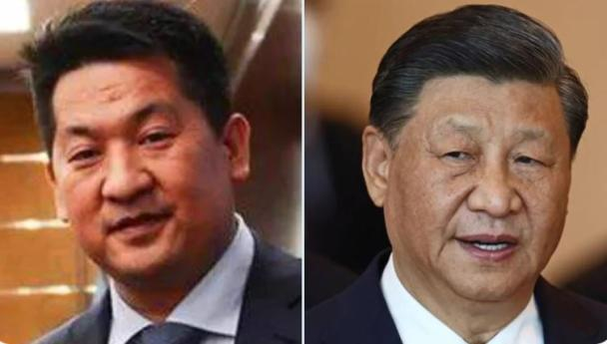

Left: She Zhi Jiang Right: Xi jinping

Due to the MSS’s pure Manchurian background, this department extreme hate Han Chinese people.

During the Senate investigation into suspected Chinese spy Guo Huaping or Alice Guo, she claimed her life was in danger and refused to say who was behind her. Many people assumed she was afraid of her two superiors, Wu Duanren吴端仁 and Wang Shuiming王水明. But both Wu and Wang are currently fugitives wanted by Philippine and Chinese governments—they can’t kill Guo. So who is Guo really afraid of?

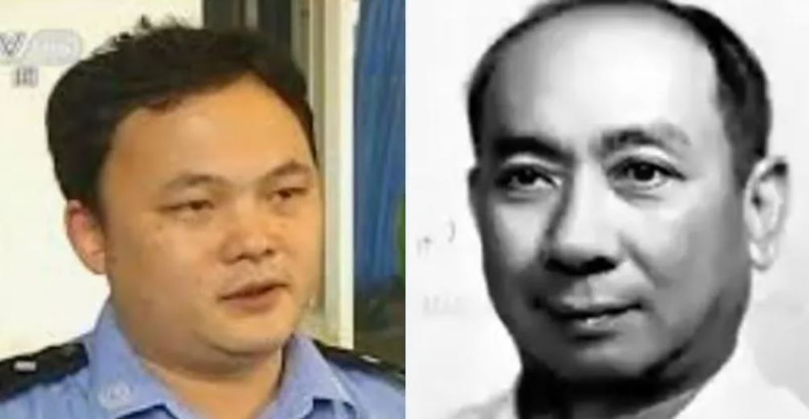

Left: Wu Duanren 吴端仁

Right: Wu Qingrui 吴庆瑞，Dr. Goh Keng Swee

As I know, Dr. Goh Keng Swee, a senior Singaporean statesman and Ramon Magsaysay Award recipient, maintained close ties with CCP leaders, especially Deng Xiaoping and Gu Mu. His family had particularly close relations with 谷牧 Gu Mu’s family. Gu Mu’s son, Liu Nianyuan 刘念远, was a senior figure in the PLA General Staff Department.

Geng Zhiyuan 耿志远, who served as MSS spy chief for south asia, he is right-hand man of Xi Jinping, as Xi once served as a personal aide to Geng’s father, former Defense Minister Geng Biao 耿飚. Geng Zhiyuan and Liu Nianyuan jointly established a so-called “Strategic Association 战略协会,” which is believed to have played a role behind several large-scale fraud cases. For example, Ding Ning 丁宁, the founder of E-zubao E租宝, was considered a low-level operative for this group.

Wang Shuiming 王水明 was once arrested in Singapore for money laundering case. After being released, he fled to Japan. Later, he attempted to enter Montenegro by private jet but was arrested upon arrival. Since then, he has completely disappeared from public view.

One blogger on WeChat published a detailed expose, revealing Wang’s alias during his exile in Japan, the safe houses he used, and the encrypted communication methods he relied on. The article even claimed that Wang used the Beidou satellite system for communication in order to avoid police surveillance.

My WeChat public account 微信公众号 quoted the blogger's article and commented: "A criminal wanted by Chinese police, yet using Chinese military satellites to evade surveillance." Less than a month later, the original article was deleted, then my WeChat account received a request for deletion. The complainant claimed to be Wang Shuiming himself, and the complaint address was in Haidian District, Beijing. It should be noted that the deletion complaint on WeChat public accounts is very strict. Sufficient legal proof must be submitted when filing such complaints. Even my response to the complaint requires detailed identity and legal proof documents. I suspect the reason is that I commented on the BeiDou satellite 北斗卫星, which is controlled by Geng Zhiyuan. And my WeChat public account was closed by chinese government in later week.

The Philippine Senate has actually ignored: the scam companies run by these MSS agents. Where exactly the money going? Which foreign organizations are benefiting?

A few months ago, many Youtubers and Taiwanese TV stations reported that Geng Zhiyuan is the mastermind behind these large-scale scam groups. Meanwhile, Several Youtubers controlled by Falun Gong spread fake news to clear Geng Zhiyuan. A Taiwanese TV station also spread similar rumors, and the guest on that show was the Jew Ross Feingold 方恩格.

The victims of POGO scam companies are mostly Chinese. But Chinese government ordered its intelligence agency — the MSS — to destroy the POGO industry. This creates a big contradiction.

The MSS (Ministry of State Security) is not a normal agency. It is run by pure Manchurians. This department hate Han people. And the money from POGO is one of their secret income sources. so they weaponized the mission to against innocent Mainland Chinese or Han ethnicity people.

Many overseas anti-China organizations — like Falun Gong, or even Muslim terrorist groups from Xinjiang — are secretly part of the MSS's Manchurian network. For example, the East Turkestan Islamic Movement (ETIM), which is called a terrorist group today, once had a very close relationship with the CCP.

ETIM and the CCP were supported by the Soviet Union in the past. The early members of ETIM were not local people. They were Muslim rebels from Soviet Central Asia *(countries like Kazakhstan and Uzbekistan)* — who had fought against the Soviet government. After these rebels were arrested, the Soviet KGB gave them special training and sent them into Xinjiang, China. Since these rebels had anti-Soviet experience, they prefer CCP. That’s why ETIM and CCP worked together before.

This is the truth behind the POGO.

The Chinoy “community leaders”, the CCP spies, and some Filipino politicians — they are all Manchurian. They have a special connection, not just political, but from the same bloodline.

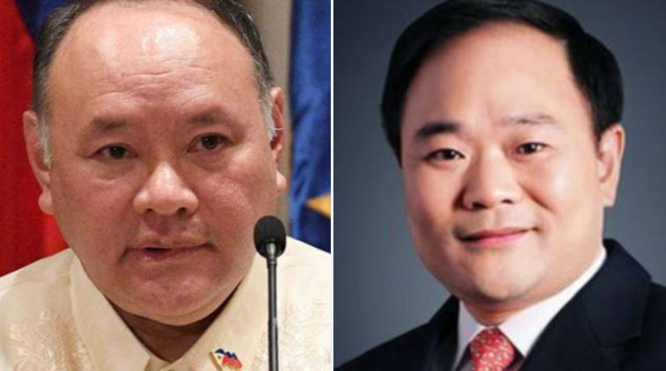

Left: Gilberto Teodoro

Right: Li Shufu 李书福, boss of Geely Automobile, husband of Xijinping wife's sister

Now the Philippine government has already arrested Guo Huaping or Alice Guo, and the Senate investigation is making the truth about POGO more clear.

People know that POGO companies connected to MSS spies. their workers in the camp treated like prisoners, not allowed go outside, and often abused.

Most of the workers are not from China. Only the bosses are Fujianese. many workers are from Vietnam, Indonesia, Malaysia, and other countries — they also can speak Chinese. Because in recent years, the Chinese government made it very risky to hire workers from China. So the Fujianese bosses found a cheaper and safer solution: hiring Chinese-speaking people from other countries.

What really happened during those years?

A well-known female chinese community leader even accused mainland Chinese of calling Filipinos "barbarians" on Rappler. The Philippine government had previously expressed discontent with this term "barbarians" towards the Chinese community. However, this is actually a term in Fujianese "Huan-a" 番阿 which mainland Chinese people generally do not understand Fujian language. Meanwhile, the lady is VIP of chinese embassy.

There was a sudden spike in violent crimes on the streets — armed robberies, shootings, abductions. Yes, crimes had existed before, but not at this scale. The mainstream media pushing strong anti-Chinese narratives. And strangely, many of these crimes were blamed on “POGO workers”, with the clear message:“Chinese = POGO = criminal.”

Do you remember when the Senate passed the SIM Card Registration Law?

Before that, scam texts were rare in the Philippines. But during the time the bill was under discussion, an unusual thing happened — suddenly, a wave of scam messages flooded everyone's phones, like someone had turned on a faucet. Then, right after the law passed, these messages disappeared — almost as quickly as they had come.

These mass-texting scam devices are widely used in China, where mobile payment is everywhere and people are used to receiving all sorts of commercial messages. The technology is advanced — but it also comes from a country where most people actually have bank accounts, making them realistic targets for scams.

But in the Philippines, very few people use mobile banking or have bank accounts. So why would such high-end Chinese scam equipment suddenly appear here, where there's barely any “market” for SMS scams?

Some are beginning to ask: Who brought that technology here? Who benefits from a sudden panic about mobile scams, just in time to pass a surveillance law? Is it just coincidence that some senators were so eager to push that law, while foreign-made scam tools flooded the country at exactly the right moment?

By the way, in the past few years, there have been many kidnapping cases targeting ordinary Chinese or Han people in the Philippines.

2022 was especially shocking —A large number of Chinese were kidnapped, some even kidnapped on the streets. According to multiple reports in Chinese-language medias, the kidnappers mostly came from one specific region in China: the Northeast — where is Manchurians came from.

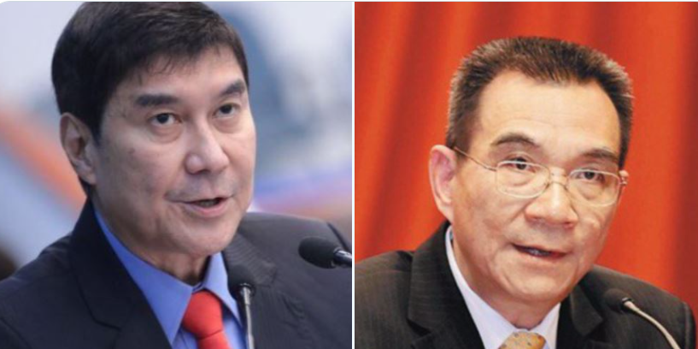

Left: Raffy Tulfo

Right: Lin Yifu 林毅夫

During all this, the Chinese embassy remained strangely silent. And the FFCCCII, a major Chinese-Filipino association known for its close ties to the embassy, said they had not seen any increase in kidnapping cases.

As someone told me those kidnappers came from Northeast were MSS chinese spies.  I went directly to the MSS’s official reporting site, 12339.gov.cn, and reported what was happening in Manila. I clearly stated that the kidnappers were Chinese spies — Manchurian MSS agents.

And guess what?

Three days later, the kidnapping wave stopped. Completely.

Actually, many of us started to wonder: is it just a coincidence that the anti-China movement in the Philippines got stronger after <World News> exposed FFCCCII's secret anti-Chinese meeting?

Let’s be clear: the Chinese Embassy, which is closely connected to FFCCCII, is also deeply tied to the Manchurian network. Just look at the ethnic backgrounds of past ambassadors:

Fu Ying – *Mongolian*

Liu Jianchao – *from Jilin, Northeast China, Manchurian*

Zhao Jianhua – *Manchu ethnicity (Manchurian-nobles)*

Huang Xilian – f*rom Fujian, a islamic province. ( the only civil war between Sunni and Shia Muslims in China happened in Fujian province.)*

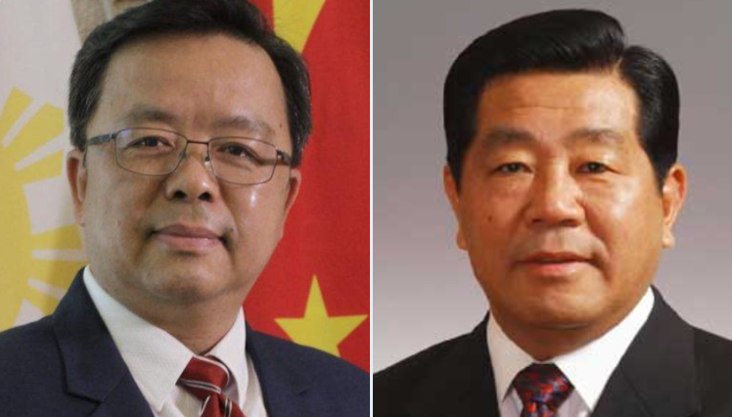

Left: Huang Xilian, china embassador 黄溪连

Right: CCP leader Jia Qingling 贾庆林, who promote Xi Jinping in Fujian province. Xi jinping alleged join the CIA in 1980s introduced by George Bush

Rumor said former Chinese Vice President Wang Qishan who is connected to the Jewish Rothschild family is the true boss behind FFCCCII.

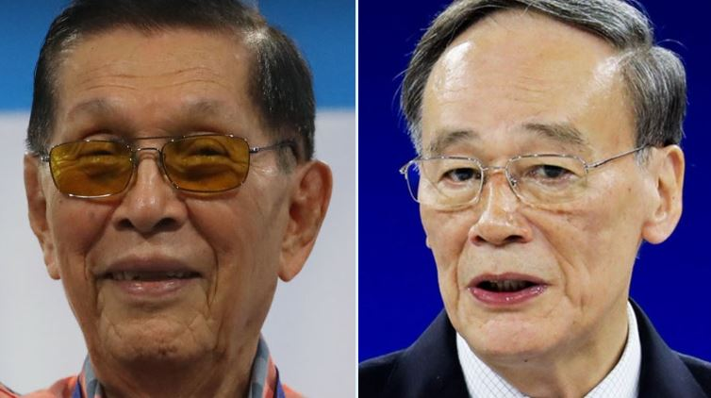

Left: Juan Valentin Furagganan Ponce Enrile Sr.

Right: Wang Qishan 王岐山

Back in 2020, during the pandemic, I donated a few face masks to the Philippine Vice President. After that, several FFCCCII members started threatening me. These Chinoy elites often act like they’re better than everyone else. They use their connections with politicians to bully Chinese from mainland. My small donation broke their monopoly over political access, and they were angry.

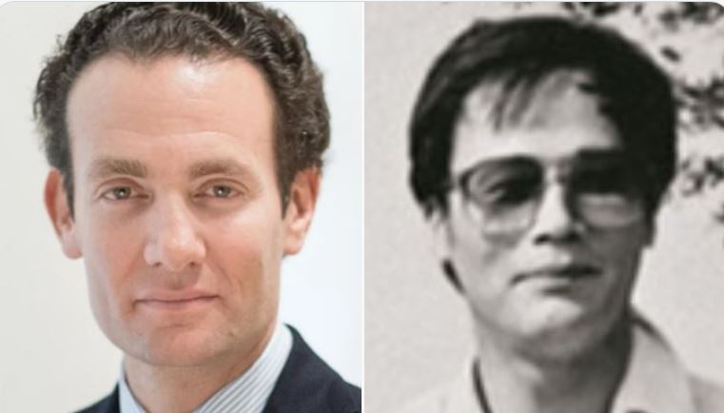

Left: Alexandre de Rothschild

Right: Wang Qishan

By chance, a powerful Chinese-Canadian businessman — who’s a close friend of mine — was also a trusted guy under Wang Qishan. So I told him everything, and he passed my complaint directly to Wang. Wang Qishan became very angry on me. He thought I was investigate his secrets.

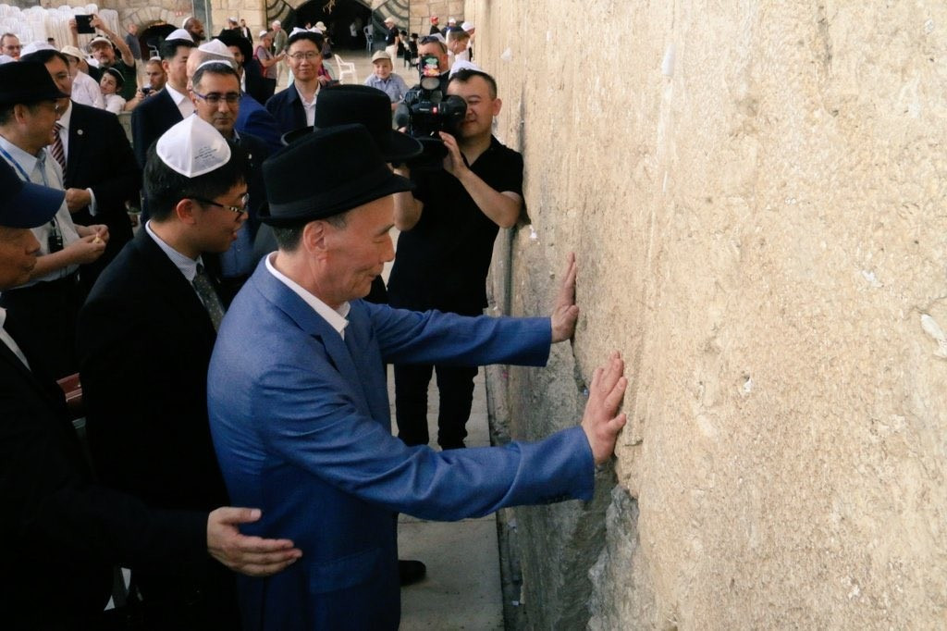

Wang Qishan

Then came 2024, the worst year for anti-Chinese movement in the Philippines. In October, a source told me that Wang Qishan was secretly arrested by China’s anti-corruption agency then quietly released. Just a few days later the anti-Chinese movement in the Philippines suddenly stopped.

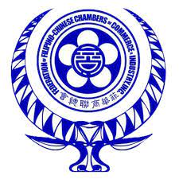

The LOGO of FFCCCII is from Manchurian worship Svayambhu 索永布 . This is actually the spiritual totem of the Mongolians. You can buy many similar logos in China.

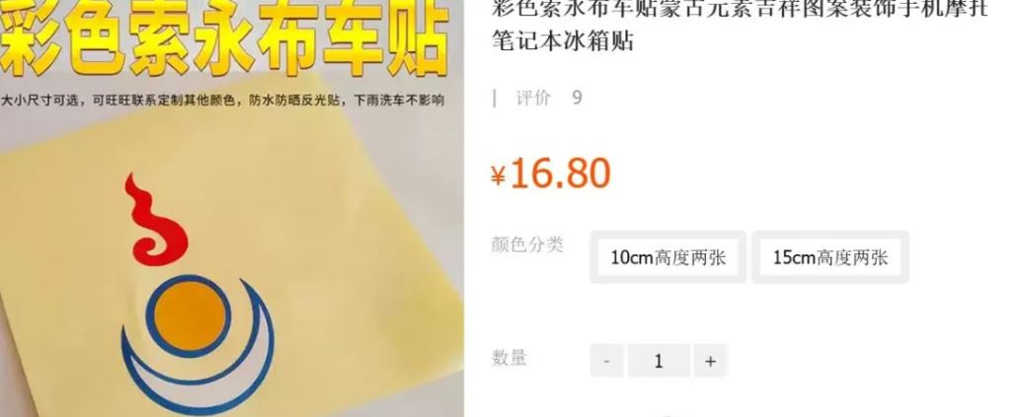

It is rumored that Hainan Airlines, the company controlled by Wang Qishan, it seems to use a similar logo 索永布.

This year, I observed that anti-chinese discussions on the Philippines Defense Forces Forum (PDFF), a platform popular among military personnel, appeared to echo similar views with FFCCCII. Interestingly, the PDFF uses Tapatalk, a forum hosting service officially registered in the US.  However, based on my past experience as an IT executive in Hangzhou in 2012, i had talked with their persons, they were Fujianess develope in Fujian. As their product focus on forums, what i interesting is how did they deal with the regulation. because in Hangzhou, a similar product PHPWIND have to sell to Alibaba due to regulation problme. Their answer is perfect, they not run business in China.

There have been circulating reports and rumors regarding the possible connection between the new Bureau of Immigration Commissioner, Norman Tansingco, and the FFCCCII. Some individuals have raised concerns about the actions of immigration agents under his leadership, including allegations of detaining mainland Chinese citizens without proper legal procedures. However, these claims remain unverified and there has been no official confirmation or substantial evidence to support them.

In fact, Philippine Nationalists also understand their politicians not "real" Filipino, as they said:

*“These politicians all have facial features like white people — they must be the children of white men who fuck with Asian women. Probably spies...”*

These nationalists often assume that these politicians are U.S. agents, not Chinese ones, simply based on their facial features — which they associate with Western bloodlines.

Especially, the anti-chinese position makes nationalists assume they were U.S spies. Filipino nationalists don't know the background of chinese history, since 1279 until today, China was dominated by Manchurian. CCP is a manchurian regime, their Spies not chinese people but manchurian or Chinese Jew. as the Jew hate Han people. so the CCP Spies has an anti-chinese point of view is match the logical.

But here’s the twist: The true origin of this “Manchurian lineage” is China itself. Historically, the Manchurians played a dominant role in Chinese history, especially during the Qing Dynasty and CCP regime, when they ruled over the Han majority.

Even some senior CIA executives, as well as Elon Musk, have Oriental facial features. The oriental facial features of the American Jewish elite are derived from China's Manchurian history. They infiltrated China 1000 years ago. They have been deeply embedded within the Chinese political structure for centuries — long before any Cold War spy theories emerged.

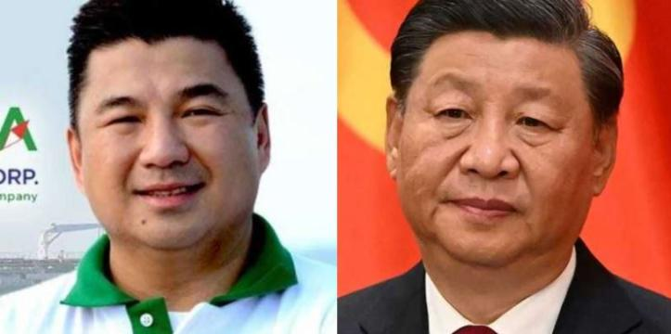

Left:DennisA.Uy

Right: Xi jinping

Some Filipino officials are very friendly toward us Chinese people — and even more so toward the Chinese government. I understand they disillusioned about Philippine politics. As they thought some Filipino politicans were U.S spies, they were Fake Filipino, their face have white features.

I hope Filipino officials can learn to distinguish: be friendly to the Chinese people, but stay extremely vigilant toward the Chinese government.

Chinese politicians same like yours, they also have white features on their faces — high noses, thick eyebrows, foreign eyes — because they are “Fake Chinse”.

Filipino nationalists once told me how they dreamed of making the Philippines great again. Some proposed parliamentary struggles. But I believe they missed the root of the problem: the Filipino-Chinese.

Philippines is a capitalist country. And in a capitalist society, those who control the wealth also control the media, the politicians, and the narrative. This is true in America, in Europe, in Britain—and it is true in the Philippines.

Some Filipino-Chinese also "Fake Chinese", they were Manchurian or Chinese Jew. The so-called “Chinese businessmen” control nearly all the wealth in the country. Therefore, it is no surprise that they also dominate the media and influence the government behind the scenes. The Filipino people will never reclaim their sovereignty through voting.

Anti-Neo-colonialism!

**Manchurian Network**

Philippines has many foreign communities, like the Koreans, Japanese. But they don't have the so-called "community leaders" nor do they have associations that cooperate with embassies for intelligence activities.

The Spy Network of the Chinese community stems from the intelligence network of the Qing Dynasty. The CCP is the successor to this intelligence network.

The Philippines has two national security threats: one is China, and the other is Malaysia.

Yes, Malaysia is also another stronghold of the Manchurian network. In fact, the entire Southeast Asia Manchurian spy network was established by Zhang Bishi 张弼士 , a Qing dynasty intelligence officer. The well-known Chinese wine brand, Changyu Wine 张裕葡萄酒, belongs to his family.

Zhang Bishi, as a Qing dynasty intelligence officer, established the Chinese Chamber of Commerce 中华商会 in Malaysia as an intelligence network.

The relationship between the Chinese Chamber of Commerce and the Qing dynasty embassy was similar to the relationship between the Chinese associations in the Philippines and the Chinese embassy. The Chinese associations would handle dirty work that the embassy could not do directly, such as threatening dissenters. I am famous in the Chinese community, because when I first arrived, some members of the FFCCCII threatened and cyberbullied me, attempting to scare me back to China. That incident of cyberbullying is what made me famous in the Chinese community.

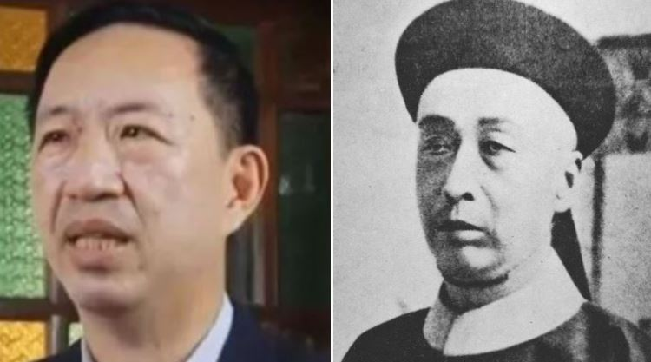

Left: Wilson Young Lee-Flores 李天荣

Right: Zhang Bishi 张弼士

At that time, the Chinese Chamber of Commerce had already spread throughout Southeast Asia, and many of today's Chinese associations are still connected to it,  like Malaysian Chinese Association. Also including the FFCCCII.

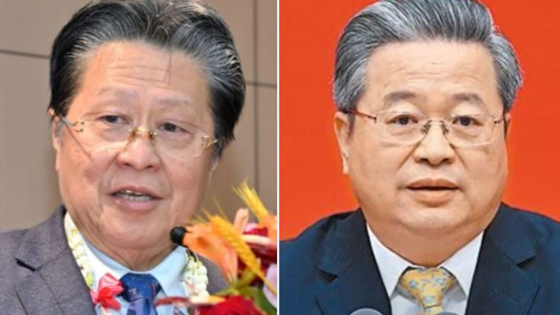

Left: Dr. Cecilio Kwok Pedro 施东方 , former chairman of FFCCCII

Right: Chen yixin 陈一新 Chinese spy chief Minister of State Security of China , the boss of MSS.

The FFCCCII was founded in 1954, but its true rise in power came in 1967 when it absorbed the Chinese Chamber of Commerce 中华商会. The predecessor of the Chamber was the "Small Luzon Chinese Commercial Bureau," 小吕宋中华商务局 established in 1904, and it was renamed the Chinese Chamber of Commerce in 1927.

The Li qingquan (Li Ching-Chuan) family and the Yu I-Tung family were key figures in the Chamber. Today, the influential Li and Yu families in the FFCCCII are actually the inheritors of the legacy of the Chinese Chamber of Commerce.

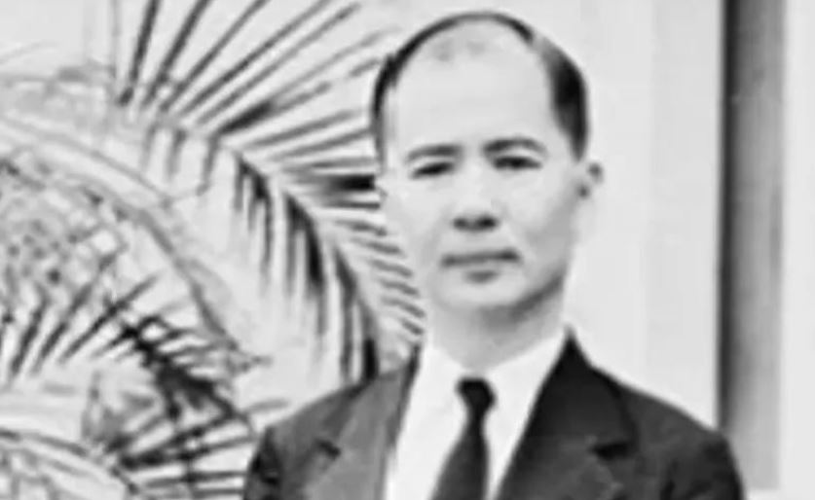

Li qingquan 李清泉

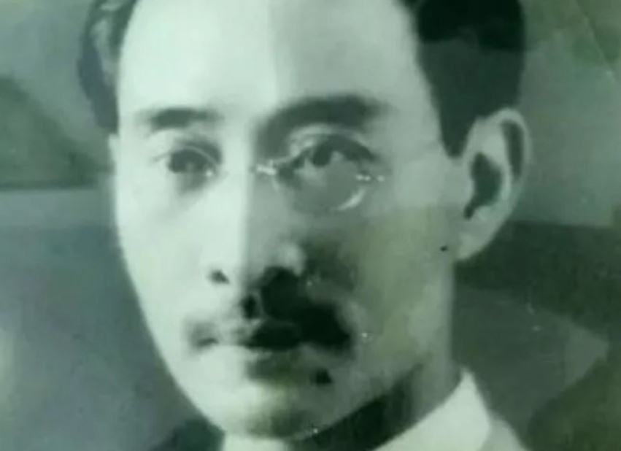

Yu I-Tung, 于以同 from LiaoNing province, Machurian-nobles , 尼玛哈氏 Nimaha Hala Family

The relationship between the FFCCCII and the Chinese Chamber of Commerce is similar to that between the newspaper “商报” and “华侨商报”. The latter was founded by Mr. Yu I-Tung, upon invitation from Mr. Li Ching-Chuan, who was the then-president of the Chinese Chamber of Commerce.

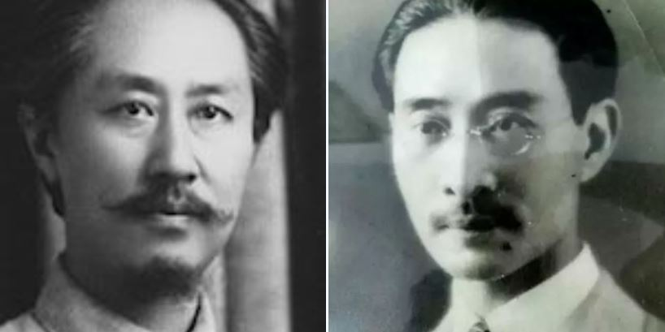

Left: Li shizeng 李石曾 Manchurian-nobles,

Founder of the Communist Party of China, helping early CCP leaders to go to France for spy training 赴法勤工俭学

Right: I-Tung 于以同

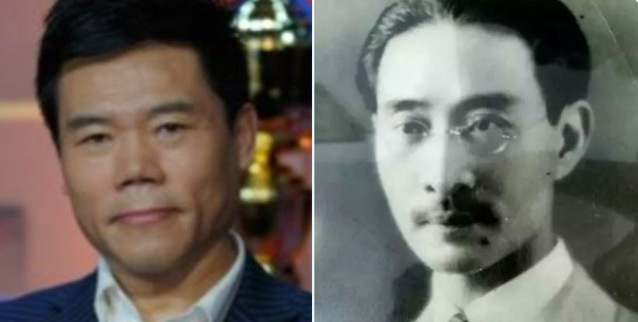

Left: Yu li or 司马南 famous Manchurian in china

Right: Yu I-Tung

Mr. Yu I-Tung’s “Yu” family name is actually an fake name. Most Manchurians use Han fake names to conceal their true origins. His real family name is from the Nimaha Hala 尼玛哈氏— a noble Manchurian. His ancestors were officials of the Qing Dynasty which was a Manchurian regime.

*Backgrund: After fall of manchurian regime Qing Dynasty in 1911, the Han ethnicity people revenge and kill the manchurians due to their large-scale massacred Han ethnicity in past time. like the Qing capital BeiJing has 1 million population and 80% is manchurian. as no ID card that time, so they posing as Han ethnicity people to avoid to be killed. mostly they using similar sounding fake chinese name. like 关 mostly is 瓜尔佳氏 and 阎 mostly 完颜氏 etc...*

Originally, Yu I-Tung’s family came from Liaoning Province in northeastern China. Later, they were dispatched by the government to Fujian, and eventually migrated from Fujian to the Philippines.

The family of Yu I-Tung was from a poor Manchurian-noble background. He had a wealthy friend, Li Qingquan, and the two families had been family friends for generations. Such relationships were not uncommon among the Manchurian elites.

During the Qing Dynasty, Han Chinese were enslaved by the Manchurians, and those who served the nobility were called 包衣 BaoYi slaves, which had better conditions than field slaves. At the end of the Qing Dynasty, the government prohibited Manchurian nobles from engaging in business, and many wealthy nobles were arrested. However, this policy had a loophole—it didn’t prevent BaoYi slaves from engaging in business. So, you would often see poor-looking nobles accompanied by a wealthy individual. This wealthy person would claim to be a BaoYi slave, but in reality, they were just a proxy holding the assets for the noble. These BaoYi slaves were not Han Chinese, but were often the illegitimate children of Manchurian nobles or distant relatives posing as Han Chinese slaves.

Unfortunately, many Chinoy business families can trace their origins back to the Qing Dynasty.

There was once a well-known historical event in Chinese history was happen in Manila.

Tao Chengzhang陶成章, and Zhang Taiyan章太炎 came to Manila to raise funds for the Han Ethnic revolution. However, Sun Yat-sen 孙中山 reportedly instructed a certain Chinese community leader in Manila to sabotage their fundraising efforts. As a result, Tao and Zhang failed to secure the needed funds, and their conflict with Sun Yat-sen intensified. They subsequently published the "Statement of Opinion from Seven Provinces of the Tongmenghui" 《同盟会七省意见书》 in the 《南洋总汇新报》 *(Nanyang General Association Gazette)*, which was referred to in historical records as "The Accusations Against Sun" 《孙文罪状》 Later, Sun Yat-sen sent Chiang Kai-shek 蒋介石 to assassinate Tao Chengzhang.

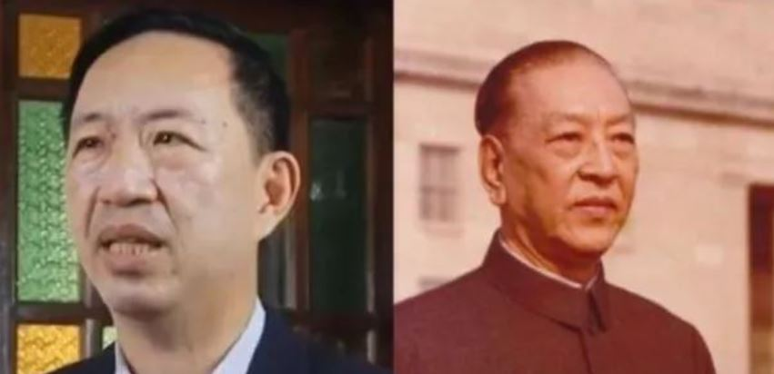

Left: Wilson Young Lee-Flores

Right: Geng Biao 耿飚 , Xi Jinping once worked for Geng Biao, the former Chinese Defense Minister and father of Geng Zhiyuan.

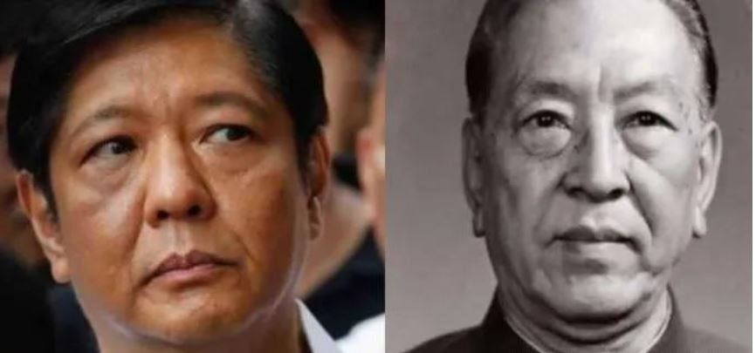

Left: BBM

Right: Geng Biao

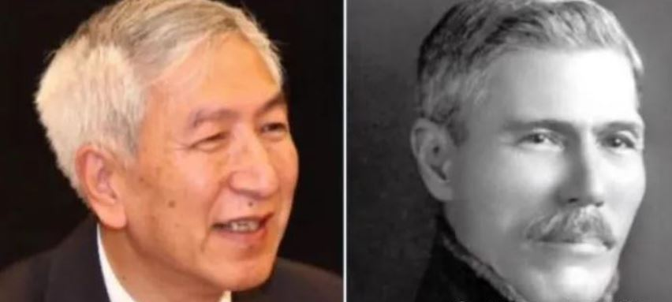

Left: Geng zhiyuan 耿志远 Geng Biao’s son

Right: Robert Hotung (Bosman)

Behind this story, who was truly responsible for undermining the fundraising efforts of these Han Chinese revolutionaries? It is very likely that it was the founding families of FFCCCII: the Li qingquan (Lee Ching Chuan) 李清泉 family.

A descendant of the Li qingquan family is Wilson Young Lee-Flores, a well-known media figure in the Philippines today. The Yu I-tong family, meanwhile, owns the Chinese Commercial News (商报). they were family friends for generations.

Wilson Young Lee-Flores (李天荣) once claimed that his ancestors had financially supported Sun Yat-sen. If that is true, then the party who sabotaged Tao Chengzhang’s fundraising efforts—under Sun Yat-sen’s orders—was likely the Li qingquan ( Lee Ching Chuan 李清泉) family.

Furthermore, the Chinese Chamber of Commerce (中华商会) functioned as a intelligence network for the Qing government. Given that Sun Yat-sen received financial support from them, it strongly suggests that he may an agent of the Qing government, planted within the Han nationalist revolutionary movement. This is why if Sun Yat-sen involved in a revolution, Han ethnicity revolutionaries were massacred in large-scale.

**The Manchurian**

Many people simply categorize "Manchurian" as Jews or Muslims, but this approach is actually inaccurate and can lead to misunderstandings and controversies. Indeed, they have some connections with Jews and Muslims, but they are very different from the Jews and Muslims of today. The key point is that their belief system is based on ancient doctrines. In ancient times, the beliefs of both were fully integrated, being both Islamic-Jew and Jew-Muslim.

Manchurian is not the same as the Manchu Ethnicity, which was a fabricated concept created by the CCP after the founding of the country. Only the elite within this group are Manchurian-nobles, while the rest of the population has mixed bloodlines. The CCP is controlled by Manchurians, and their purpose in creating this fake ethnicity seems to have been to use these innocent people as a shield to deflect the wrath of the Han people seeking revenge.

The term "Manchurian" is indeed recorded in the Song Dynasty's (960-1279) intelligence documents.

In 1040s–1060s, a group of ancient Muslim businessman come and settled in then Song capital KaiFeng city in Henan province, they called themselves the Israelites. They applied to the royal family to establish a religion: Israel. 一恩乐也教 This religion continues to operate in China untill today, which was the forerunner of modern Judaism. The word Jew had not yet been invented at that time. They was recorded in intelligence documents as: Blue Hat Muslims. 蓝帽回回

In the year of 1115, they established a Jin State 金国 in the Manch area, Manchu like Cebu, Visaya, mean the Northeast of China.

In the year of 1221, then Song dynasty government defined them as Black Tartar in the book of “Record of Mongol-Tatar” 蒙鞑备录

"Tartar" usually referred to invaders from the north, mainly white people. However, this group was not the traditional Tartar. The leadership of their army was composed of white individuals, while the lower ranks included many black people. Even the Song Dynasty intelligence officers noted that they were very different from the traditional invaders from the northerns. some intelligence documents, like ““Record of Mongol-Tatar” 蒙鞑备录, “The Record of Black Tartar” (黑鞑事略), specifically named them "Black Tartars."

The document clearly said “Mongol” is the fake name of Black Tartar, and their leadership is from Jin State. The “real mongol” were not inland nomadic tribes, but rather a fishing ethnic group along the Northeast coaste of Asia, they wears shark skin armor and good at night combat. consumption of shark liver may have contributed to their famed prowess in night battles. they even succeeded in defeating the Jin State army in battle. 建炎杂记乙集卷二十

In fact, with today's advanced research tools and data collection, it is no longer accurate to define them as “Tartar”. In reality, they did not come from the North, but rather from the direction of India and Myanmar, entering Yunnan Province from the south, and then traversing the Qinghai-Tibet Plateau to eventually reach Northeast Asia.

This group of people is actually Arab. In the spring of 801, the Abbasids, allied with Tibet, fought against the Tang Dynasty army, and eventually, 20,000 Abbasid soldiers surrendered. These people are the earliest source of Muslims in Yunnan. One group of them moved south, becoming the Jews in the Golden Triangle and Thailand, while another group bypassed the Qinghai-Tibet Plateau and reached Northeast Asia. They also became the source of Jews in the Russian Far East. The Jewish Autonomous Province in Russia borders Northeast China.

If you read ancient texts and the books of ancient Islamic travelers, you will find that ancient Islam was very tolerant and had no major taboos. In the ancient Islamic army, Jews and Muslims fought side by side, proving that their doctrines were completely inclusive. They seemed to care more about political or strategic cooperation rather than doctrinal conflicts. This is completely different from the hostile relationship between modern Islam and Judaism.

How can we understand that ancient "Islamic-Jew" and "Jew-Muslim" were completely inclusive products? You only need to look at another Manchurian province—Fujian. many of Filippino-chinese came from Fujian.

During the Song Dynasty *(960–1279)*, Arabs had already established spy networks in Fujian. During the Song-Mongol war, the Muslim leader of the Arab maritime family, Pu Shou-Geng 蒲寿庚, took the opportunity to kill the entire Song royal family in Fujian. After the Song government collapsed, the Muslims in Fujian continued large-scale ethnic massacres of the Han people. Eventually, all the Han people were killed, and Fujian became a province with a purely Muslim population. How pure was it? The only Sunni-Shia civil war *(1357-1366 亦思巴奚兵乱 or “سپاه”sepâh)* in Chinese history happen in Fujian. This shows that the population of Fujian at the time was almost entirely Arab, with no Han people left.

*More about the Sunni-Shia civil war: After the Sunni leader Pu Shou-Geng massacred the Song Dynasty royal family, he received support from the Yuan Dynasty government, which allowed the Sunnis to gradually gain power in Quanzhou, Fujian Province. This pushed out the Shia community in Quanzhou, causing discontent among the Shia. In 1282, the Yuan Dynasty sent 3,000 Shia troops to guard Quanzhou, and Shia residents from Persia a militia, gradually strengthening their power. In 1357, while the Yuan government was struggling with the Han Chinese White Lotus Sect revolution, a Shia general rebelled and took control of Quanzhou, beginning a campaign of revenge against the Sunnis. The Islamic civil war broke out.*

The Muslims in Northwest China are connected to Central Asian Muslims, so their doctrine is more extreme, and their doctrine is modern Islamic. However, Fujian, being surrounded by Han Chinese provinces, maintained the ancient, inclusive teachings of Islam. For example, Fujian has many Islamic-Buddhists, whose numbers surpass those of Islamic-Muslims. If you can understand Islamic-Buddhist, then you can understand Islamic-Jew.

In Fujian, the Muslims had an open-minded religion. They didn’t have many rules. For example, in Alice Guo's village, the family name “Guo” were Muslims, but her father worked by killing pigs. In Zhejiang, a Zhejiang Muslim man named Ma Yinchu was a population expert, and his family made alcohol. Another Muslim, Guo Congyuan  or Anson Que, who was a news figure because he was murdered in the Philippines, was the leader of the Muslim Association of Fujianese people in the Philippines. He also didn’t follow strict religious rules.

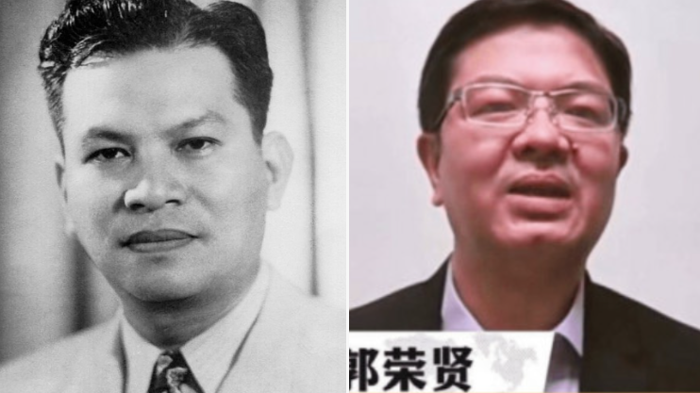

Left: Ramon Magsaysay, former Philippine president, the establishement or FFCCCII was inspired by Ramon Magsaysay

Right: Alvin Que, the son of Filipino-Chinese businessman Anson Que 郭荣贤 Anson Que , who was kidnaped and killed. he is the king of philippine steel industry and a Muslim Leader. 郭从愿

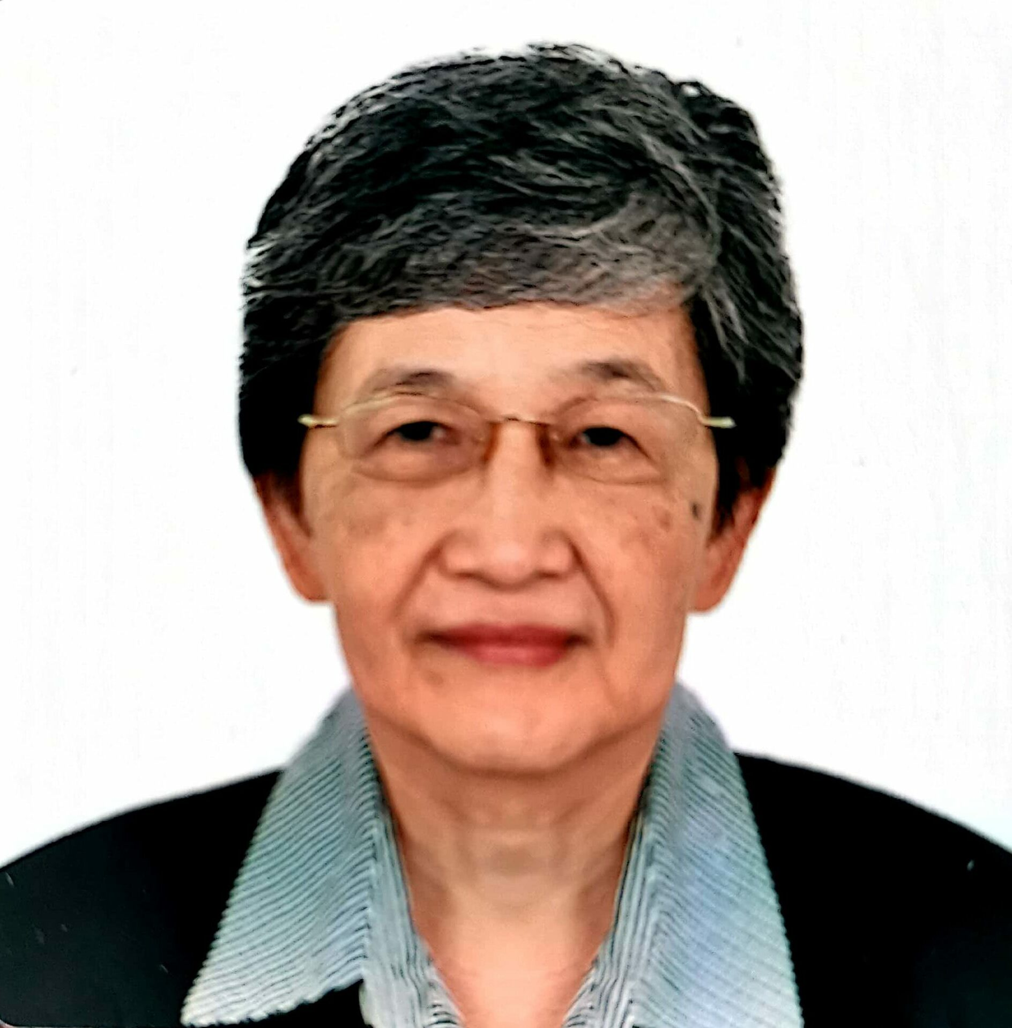

More: about Teresita Ang 洪玉华 who behind Adson Que’s case. Ang is a famous anti-kidnap chinese community leader. But in 2020, she promote chinese hate on Rappler meanwhile she is a VIP of chinese embassy. Her housband was close to “Chinese Commerce News” 商报 which is a newspaper relate to FFCCCII. they has found the Pagkakaisa sa Pag-unlad which is closed by Philippine government due to they were a part of Communism. In 2022, A large number of Chinese people were kidnapped by kidnappers from Northeast China who alleged MSS spies. She denied at the FFCCCII meeting that there were a large number of new kidnapping cases. In 2025, she helps a filipino boy gets new liver in successful transplant in ShangHai hospital.

<https://www.pna.gov.ph/articles/1245777>

Chinese tradition prohibits organ donation. Organ transplantation is controversial in China. Because organs often come from missing children and Falun Gong practitioners. The black industry is rumored owned by MSS, and China has an extremely advanced facial recognition cloud network. But missing children in China are often denied search by police. The children's bodies, with their organs removed, would then float on the river. Similar news has been reported by the media many times in China, like the Hu Xinyu 胡鑫宇 case. Including Dr. Luo Shuaiyu 罗帅宇 of Xiangya Hospital, who was assassinated for exposing illegal organ procurement.

<https://chinascope.org/archives/36202>

Teresita Ang should provide the public with the source of the child’s liver, as well as the DNA link report of the organ’s parents. To avoid organs being obtained from murder, which is popular in China.

After a civil war broke out between Sunni and Shia Muslims in Fujian province, both groups were later suppressed by the government. To escape further persecution, they began migrating deeper into the inland areas of China. The Han Chinese population in Fujian only moved in after this conflict. For example, the Pu Shougeng 蒲寿庚 family fled to Yunnan province —where Manchurians came from. The wife of former CCP leader Deng Xiaoping was a native of Yunnan and a descendant of the Pu Shougeng family.

The famous Muslim navigator and intelligence officer Zheng He 郑和 from the Ming Dynasty is also believed to be from the Pu Shougeng family. Since Yunnan is an inland province with no access to the sea, it would have been unlikely for a local person there to become a great seafarer unless he had foreign knowledge or connections.

Meanwhile, the Muslim warriors moved to Jiangxi province and settled in a city called Ji’an 吉安. In Han Chinese pronunciation, “Ji’an” sounds similar to “Zion.” Early armed bases of the CCP were located in Jiangxi, and many generals came from Ji’an city. The Muslim nobles fled further inland to Hunan province. Interestingly, many top CCP leaders came from Hunan.

If we want to understand why ancient Islam and Judaism were once totally blended together, we can look at the Manchurian tradition of strategic deception — something they mastered through what some called “fabricated identity” tactics. This blending wasn’t a result of “tolerance” or “coexistence” as modern scholars describe, but more like they were always one group in different disguises.

Back then, Jews were not called “Jews” but “Israelites.” Even in English, you can notice how the pronunciation of “Islam” and “Israel” sounds similar.

When they were Jin State people, meanwhile they claim to be fake ethnic Mongol.

When they were Manchurian nobles in Qing Dynasty, after fall of Qing they claim to be fake Han ethnicity people.

When they were manchurian from china, they clime to be Filipino-Chinese in Philippine. They are neither Chinese nor Filipino.

The narrative that Islam came from Judaism looks more like how the Manchurians traveled from Yunnan to the northeast, first calling themselves the Jin State, and later pretending to be Mongols — even though they were the same people all along, just under different masks. The current tension between Jews and Muslims may just be another level of strategic deception — to make the world think they are enemies, when in fact they might still be part of the same historical alliance.

The way these Manchurian invaders expanded was very different from other invaders in history. They liked to pretend to be part of a local group, and then kill all the original people. For example, in old Chinese records, the Uyghurs in Xinjiang were yellow-skinned people who believed in Buddhism. But today, the Uyghurs are white-skinned people who believe in Islam. Without doubt, just like what happened in Fujian, the real Uyghur people were all killed.

I call them “Manchurian,” but some people might say they were actually Arab people who came from Yunnan and entered Northeast Asia. They were not the original people of the Manchu area. What I want to say is, they have been in Northeast Asia for almost a thousand years. Based on how they usually invade — by replacing local people — it’s very likely that the real local people of Manchu area were all killed. So today, these invaders have become the “real” Manchurians...

The Manchurians seem to have some blood connection with the British royal family. They often pretend to be part of other ethnic groups. The first time Chinese intelligence discovered them was in the Song Dynasty, in the capital city of Kaifeng. Back then, they were called “Blue Hat Islam.” They followed a religion close to Judaism, but it was not the same as modern Judaism. In fact, many parts of modern Judaism were stolen from Han Chinese culture.

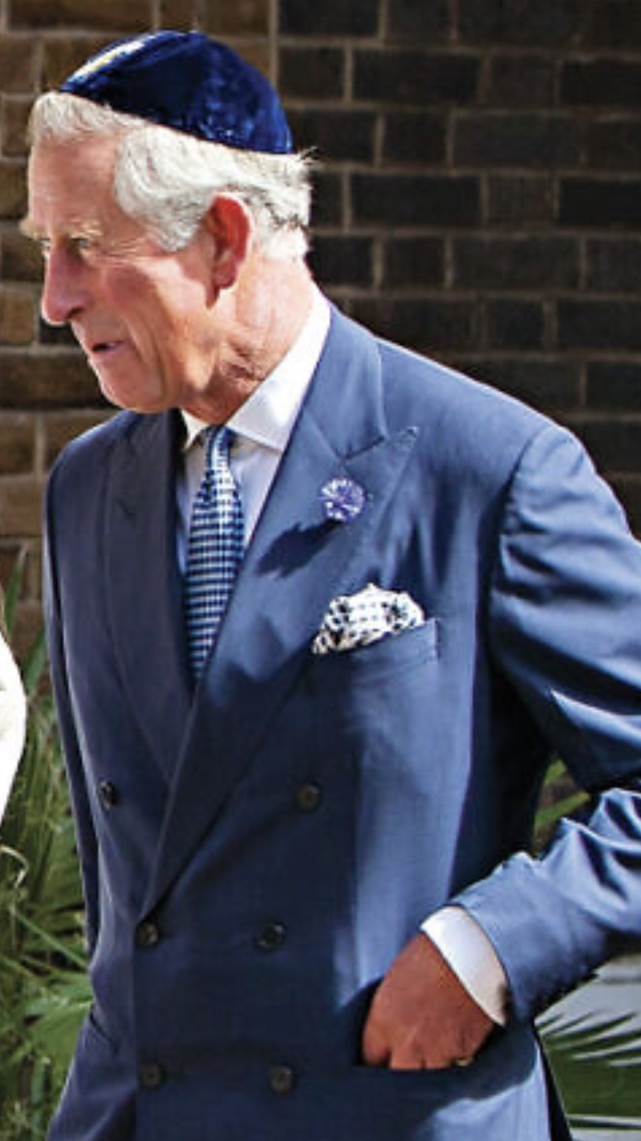

Manchurian has extremely close blood ties with the British royal family. Is it possible that Charles is a blue hat Muslim?

At that time, their religion was not called “Judaism” or “Jew.” It was called the “Religion of Israel,” and my ancestors, who were part of the Song Dynasty royal family, gave them official permission to set it up. This religion still exists in China today, and it is known as “Yi Si Le Ye” (一赐乐也), which is the Chinese phonetic version of “Israel.” They called themselves “Israelites,” not Jews.

This ancient Jewish belief seems closer to what is described in the Old Testament of the Bible. Modern Judaism, on the other hand, seems to have stolen many elements from Han Chinese culture.

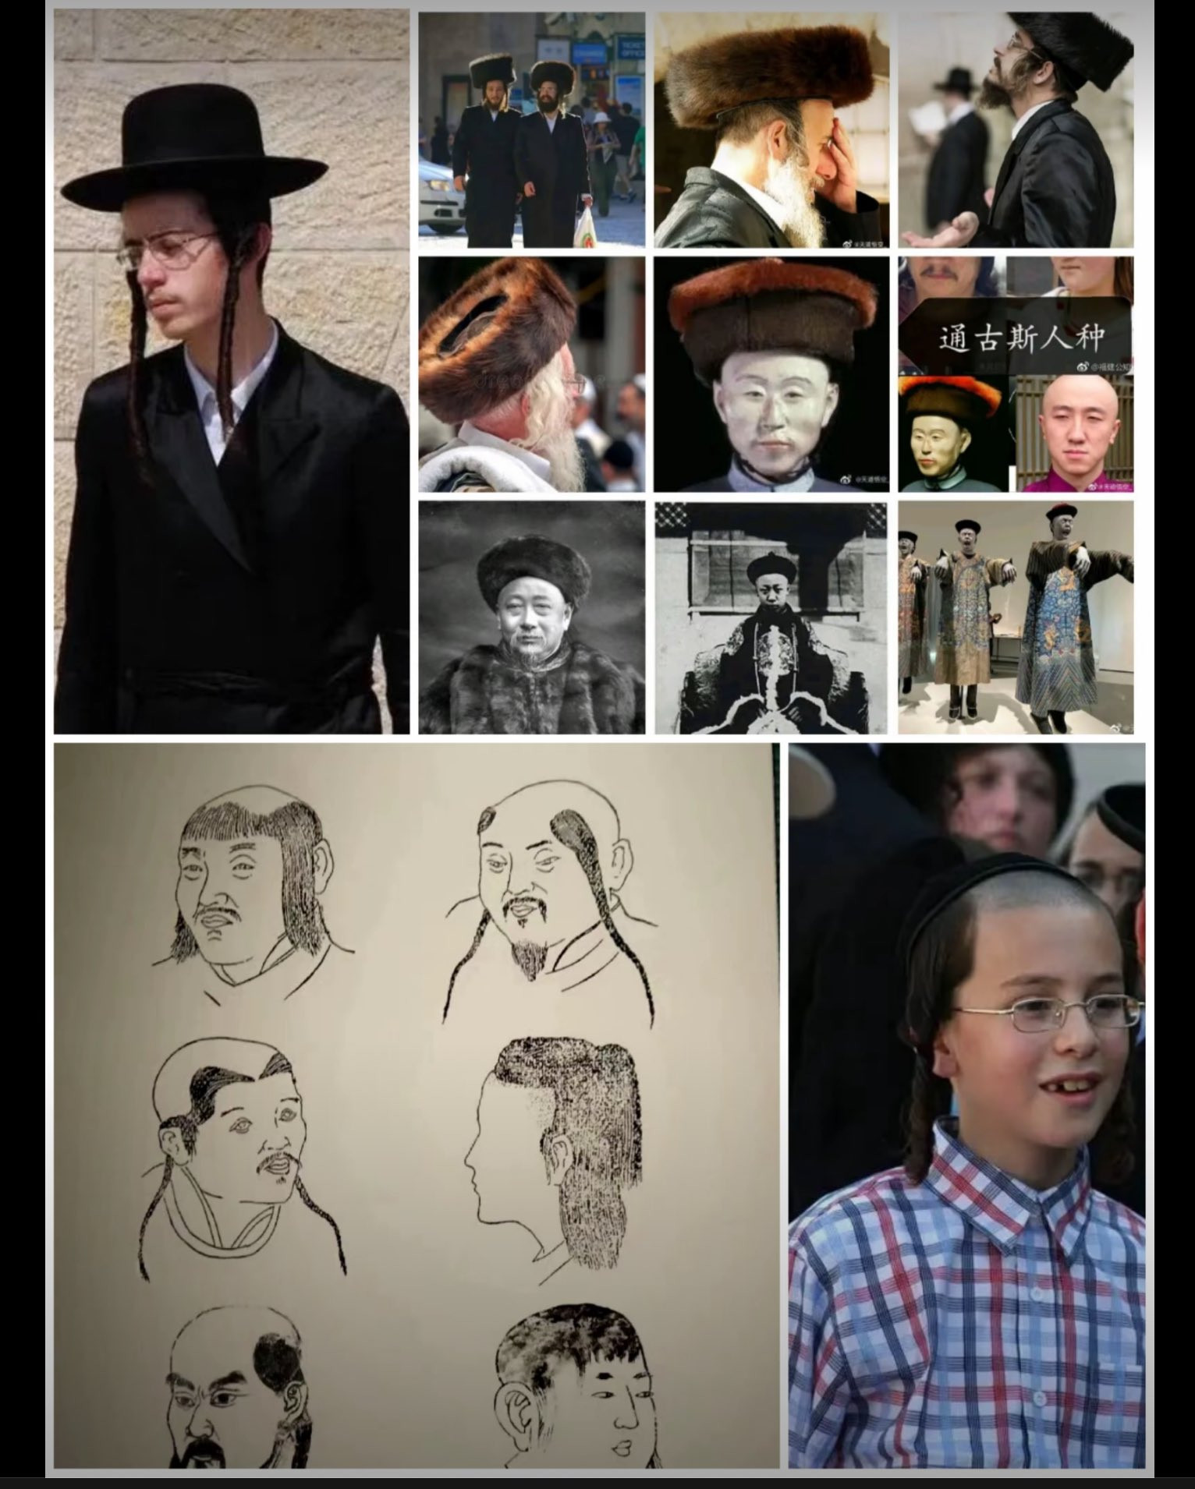

So called Jew , already record in acient chinese book, at that time they were not Jew but Tartar. Tartar is a general term for invaders from the north, not a designation for a specific ethnic group.

The second time Song Dynasty intelligence found them, they had already changed their name and called themselves “Mongols.” This new enemy caused a lot of confusion in the military system of the Song Dynasty. Because of this, Song intelligence officers wrote detailed reports in a special document called “The Records of Mongol-Tartars.” 蒙鞑备录 They explained clearly: these people are still the same "Black Tartars" — “Mongol” is just a fake name they are using.

The real Mongols at that time were just a small fishing village on the coast of Northeast Asia. The real people there wore shark-skin armor and were very good at fighting in the night. The Black Tartar group simply stole their name and used it as a disguise.

The leader of the Black Tartars was Genghis Khan 成吉思汗. According to reports from Song Dynasty intelligence officers and also foreign diplomats at that time, Genghis Khan was a tall white man. The top leaders of the Black Tartar army were also white men with big beards. But in the lower and middle levels of the army, there were many soldiers with dark skin. These fighters were strong and brave in battle. Most likely, these dark-skinned soldiers came from the areas of India or Myanmar.

Later, the so-called “Mongols” built the Yuan Dynasty (1271-1368)  in China. When the White Lotus Sect tried to overthrow the Yuan Dynasty, their famous slogan was: “Kill all Tartars, bring back China.” But wait — if it was the Mongols who were ruling china, why did they say “kill Tartars” instead?

Because the name “Mongol” Han people knew it was a fake name. That’s why they used the word “Tartar” — the real identity of the enemy.

Starting from the Blue Hat Hui Muslims in Kaifeng, Jews began to steal Han Chinese culture.

The period from the 10th to the 15th century was the peak of Jewish theft of Han Chinese culture and also the time when Jewish theories were upgraded. It can be said that the evidence of their cultural theft lies in these theories. These theories cannot be found in either Western or Jewish traditions, but they can be traced back to Han Chinese traditions. For example, Zionism is actually a revenge culture of the Han Chinese. Even the term "Jew" does not appear in their Bible. The Bible only refers to the Israelites. So where did the word "Jew" come from? How did it suddenly appear?

According to old Song Dynasty records like <蒙鞑备录>, <黑鞑事略>, and <行程录>, the "Black Tartars" came from the Jin State. The Jin State was the first government made by the Manchurians in Northeast Asia.

The name "Jin" is a Mandarin or Manchurian pronunciation. If you use a Han Chinese way to say it, it sounds like “Jew.” So you can understand "Jin State" as meaning a "Jew State."

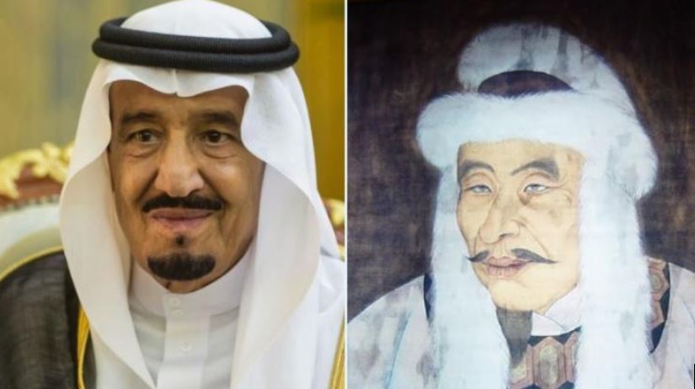

The Manchurian ancestor : Wanyan Aguda (Right) 完颜.阿骨打 who established Jew State , if you see their ancestor very like Arab people.

Now, where did the people of the Jew State came from?

Based on many historical clues, I believe they came from Yunnan, in Southwest China. Most likely, they were the same group of Arabs who surrendered in the year 801 during a war with the Tang Dynasty.

According to ancient Chinese records, I found these pieces of evidence:

1. Northeast Asia is very cold**,** and most native people there have traditions to keep warm. But the Manchurians shaved their heads, which is more like a desert tradition, not a cold-climate one.
2. It’s hard to grow grains in cold Northeast Asia, and wine is usually made from grains. But the Black Tartar leaders were heavy drinkers and had many ways to enjoy alcohol — this is more like Yunnan traditions, where wine is common. 黑鞑事略
3. Women of the Black Tartars put yellow powder on their faces. This is a custom from the Yunnan and Myanmar area. 蒙鞑备录
4. Genghis Khan liked to burn bones to tell the future. This fortune-telling style comes from the Bon religion in Tibet, common in the Yunnan–Myanmar region. 黑鞑事略
5. A Song Dynasty diplomat was given a dish made of raw pig blood. This kind of food only exists in Yunnan. 行程录
6. The Black Tartars had many dark-skinned soldiers. But you cannot find dark-skinned people like that in northern China. They only exist in places like Myanmar and India.
7. Their writing is very similar to Arabic, and they worship the moon, which is an Arabic belief that earlier than Islam. 黑鞑事略
8. When they meet, they cross their arms and bow. This etiquette is popular in the Middle East, Africa and ancient Egypt. 黑鞑事略

They liked to pretend to be other peoples—and most often they pretended to be Han Chinese. If you investigate CCP officials, almost all their ID cards is“Han.” At the fall of the Qing, Beijing had one million people, of whom 800,000 were Manchurians. When the Qing fell, these people all became Han.

Of course, this spy infiltration had been common for hundreds of years, so we don’t believe anyone who claim to be Han. We use face-style‑reading 面相术 to check if they have Western features.

There have been various discussions and speculations about the backgrounds of certain individuals in Congress who, despite appearing to have Western features, identify themselves as Filipinos. Similarly, in Binondo, some individuals with similar backgrounds are often referred to as Chinese. However, it's important to note that these are observations and claims circulating in public discourse, and no concrete evidence has been provided to fully verify these identities.

China used to be poorer than the Philippines, but now we are richer and no longer have hunger. In this high‑tech age, Filipino hunger and poverty are barriers set up by these Manchurians? The Philippines’ birth rate has already crashed. Be on guard—“the Race Replacement Plan” has begun. Once they breed enough people here, they will create disasters among the natives to reduce your population. They pulled the same tricks in the Manchu area, in Fujian, and in western China.

Some Fujianess use fake birth certificates to disguise themselves as Filipinos. This “Fake Filippino” method was frequently used by the Manchurians in China. In the past, they disguised themselves as people from the “Jin State”, as “Mongols”. After the fall of the Qing Dynasty, they all disguised themselves as “Han Chinese”. The Philippine government should label these “Fake Filipinos” as a national security threat. Yes, they are all peaceful businessmen, just like the Blue Hat Muslims who came to Kaifeng, they call themselves Israelis, just like the Arabs doing business in Fujian. They were all peaceful businessmen, but at the same time, they were actively building the spy network. When war comes, they will massacre the locals and replace the race. These “Fake Filipinos” are actually manchurians, the same group of people. Based on their 1000-year history of bad deeds in China, it is necessary for the Philippine government to list them as a serious national security threat.

In two hundred years, this will still be the Philippines, and Filipino culture will still flourish here. But the people will all have Western facial features—just like the yellow‑skinned Buddhist Uyghurs of old. Your bloodline will vanish, but your culture will live on, carried by their resilient successors—just as Han culture survives in Fujian.

Manchurians don’t just control the Philippines’ economy and politics—they dominate other Southeast Asian countries too. You’ll see their strange hatred of Han Chinese culture.

First, they deeply hate “Han.” China’s writing is called “Han zi,”汉字 but they changed it to “Hua Wen.”华文 Chinese people are “Han ren,” 汉人 but they call them “Hua rén.” 华人 China’s traditional clothes are “Han fu,”汉服 but they say “Hua fu.” 华服 Anything with “Han” becomes “Hua”—that shows their deep hatred. Yet after “de-Han-ification,”去汉化 they embrace those altered Chinese cultural templates as their own.

Manchurians were actually Arab Muslims who surrendered in the spring of 801. After infiltrating the Manchu area, they founded their own state and ruled China for centuries. In Muslim countries like Malaysia, they could openly practice Islam without fear. But they cling to their de-Han-ified Chinese cultural templates with the fanaticism of Islamic extremists.

Those politicians with Western faces shouting “Filipino” and “Filipino culture” are ridiculous. Just like another Manchurian country, South Korea: their capital used to be Hanseong (“Han City”), but out of hatred for Han they renamed it Seoul. Yet they systematically steal Han culture: kimchi came from Sichuan, rice cakes from Zhejiang, and Hanbok from Hanfu. The original Hanbok showed a woman’s breasts until the Japanese occupation forced Koreans to cover up as “decency.” Now they claim Hanfu was invented by Koreans. This shameless cultural theft started back in Kaifeng with the Blue Hat Muslim.Yes. Back then the word “Jew” had not yet been stolen—there is no “Jew” in the Old Testament. In Kaifeng they still called themselves “Israelites.”

Manchurians claim all kinds of ideologies, religions, and beliefs to create conflicts. Their real goal is to wipe out yellow-skinned people, the original inhabitants.

The Donggan Rebellion (1862–1873) was a Muslim-led genocide that slaughtered 25 million Han Chinese in Northwest China. Because top CCP families were involved, this history is banned in China—but the truth is different.

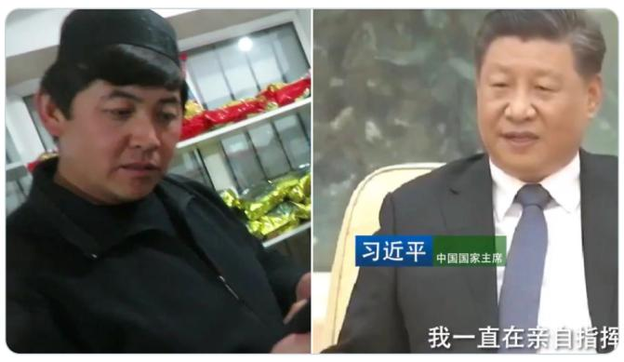

Left: Descendants of Bai Yanhu (photographed in Dong Gan Village, Central Asia)

Right: Xi jinping

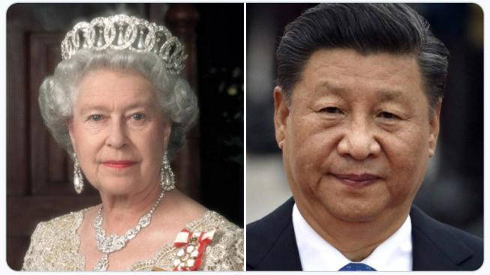

Left: Queen Elizabeth II

Right: Xi jinping

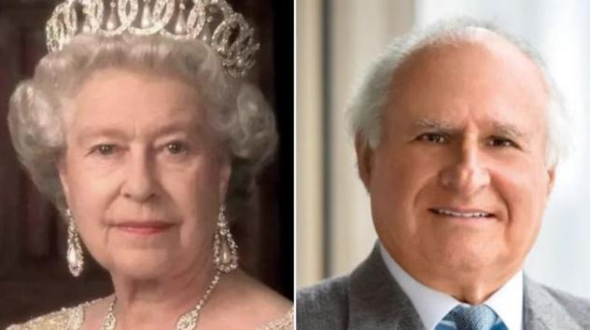

Left: Queen Elizabeth II

Right: Kadoorie

China’s president Xi Jinping has Jewish ancestry from Kadoorie family, which Related to Queen Elizabeth II. one of his ancestors, Bai Yanhǔ 白彦虎, was a Qing government official who led that massacre. Bai Yanhǔ belonged to a Sufi order—the most tolerant branch of Islam—which often clashed with the local modern Muslim groups.

So this genocide looks more like a race cleansing carried out by Manchurian officials in the Qing government, then blamed on local Muslims.

Another leader in the Donggan Rebellion (who later surrendered) was Dong Fuxiang 董福祥 . Xi Laohu 习老虎 —Xi Jinping’s great-great-uncle—served under Dong Fuxiang. He helped protect Empress Dowager Cixi 慈禧太后 and was rewarded; that reward paid for Xi’s old family house in Shaanxi.

Incidentally, Xi’s right-hand man Geng Zhiyuan (son of former Defense Minister Geng Biao) also has a grandfather who was Empress Dowager Cixi’s bodyguard.

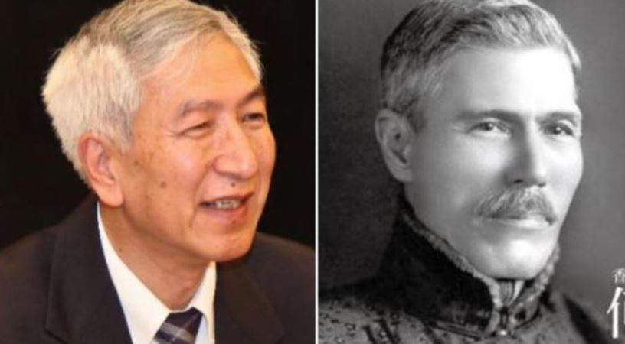

Left: Geng Zhiyuan,

Right: Robert Ho Tung Bosman

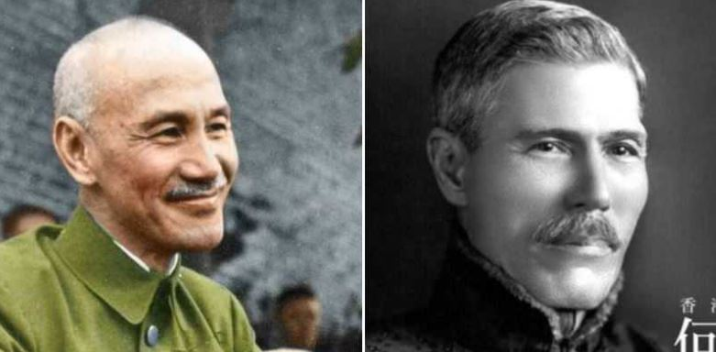

Left: Chiang Kai-shek

Right: Robert Ho Tung Bosman

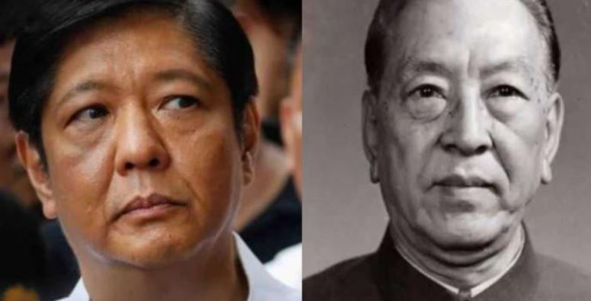

Left: BBM

Right: Geng Biao, Former CCP Defense Minister,

& President Xi Jinping’s former boss

& Geng zhiyuan’s father



Left: Wilson Young Lee-Flores

Right: Geng Biao 耿飚

In fact, similar events happen during the 2009 Urumqi riots in Xinjiang. The 75 Incident was believed to have been orchestrated by overseas Uighur activists, who used Uighur Islamic terrorists to carry out a genocide of Han Chinese. However, the truth is that the Uighur Muslim terrorists involved in the massacre of Han Chinese were not local to Urumqi (the capital of Xinjiang), but were brought in from southern Xinjiang.

Due to the large-scale transportation of terrorists from southern Xinjiang, multiple intelligence agencies had already detected these terrorists before the massacre took place. The Huang Han Movement had already posted information about the incident on their website before the killings. Even CCP agents in Xinjiang had intercepted their satellite communications, but the government prohibited them from investigating.

After the massacre, Uighur people, fearing retaliation, went into hiding. Meanwhile, CCP’s armed police forces once again carried out a genocide of Han Chinese protesters on the streets.

Therefore, from these two incidents of Muslim-led genocides against Han Chinese, certain patterns can be observed. While Muslims do engage in acts of genocide, their own death tolls are typically scattered and small in number. The Manchurian regime government Qing Dynasty and CCP, however, often takes advantage of these situations by posing as Muslims and increasing the scale of the genocide against Han Chinese to the level of tens of millions. Because Muslims have committed wrongdoings, they are in a moral disadvantage, and as a result, these tragic events are pinned on them.

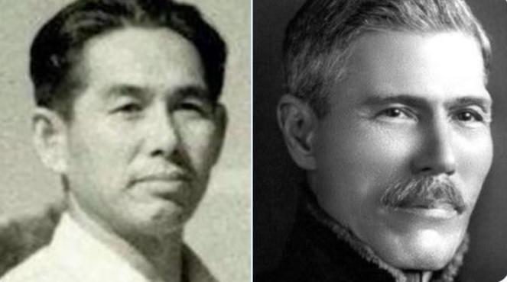

Left: Peng jia sheng 彭家声 from same family

Right: Right: Robert Ho Tung Bosman

The CCP police seized 47 rifles when they arrested the Uighur terrorists. These rifles came from the MMDAA in northern Myanmar, an armed group led by Peng Jiasheng. Peng Jiasheng’s close friend is Geng Zhiyuan, who is Xi Jinping’s right-hand man.

The Philippines’ national security threat comes from the Manchurians, whose spy nests lie in three countries: China, the United States, and Malaysia. Many high officials in the U.S. CIA—and even people like Elon Musk—have East Asian facial features because their ancestors once came from China, they were so-called Jew today. Malaysia is tied to another Manchurian story: the Ming royal family. Today some in the Chinese government claim Palawan is Chinese territory, but they hide Palawan’s Malaysian background. The U.S. government’s formation is linked to the Qing Manchurians, while Malaysia is the Ming Manchurian royal base. I will tell the full story about Malaysia in the later chapter.

**The History**

To safeguard the Philippines’ national security, we must learn China’s history. The greatest threat to the Philippines is the Manchurians—and they are hidden within China’s past. You cannot understand Southeast Asian history without China’s history. Many of the Philippines’ problems can only be fully explained by including the histories of China, Malaysia, Vietnam, and other countries.

First, let’s talk about ethnic DNA. Filipinos, Vietnamese, Malaysians, Taiwanese, Indonesians, and even Pacific peoples like New Zealand’s Māori all share Han Chinese ancestry. In theory, you are all Han Chinese, because Han ethnicity is defined by bloodline.

Western scholars once maliciously labeled this bloodline “Malay,” trying to deconstruct Han ethnic. The Malay people never invaded us, nor did they ever invade the Philippines. Molecular anthropology now shows that Filipino ancestry traces back to Taiwan, Taiwanese ancestry to Fujian, and Fujian ancestry to the Liangzhu civilization around Hangzhou in Zhejiang Province. Zhejiang is tied to many ancient myths. In other words, 5,000 years ago, Han people had already spread from Fujian to Vietnam, Philippines, Indonesia, and other Pacific regions.

Filipinos had already established the Luzon State before 1279. The Chinese character 宋 (“Song”) in Mandarin is pronounced like “Song,” but in Han pronunciation it would be “Zon.” Since Mandarin reflects Manchurian speech. it is an invader's language.

The Song dynasty was a great seafaring power. After the defeat at the Battle of Yamen in 1279 and the fall of the Han Chinese Song government, many Song people fled to the Philippines—especially to Manila and Pampanga.

*More about Battle of Yamen: During the war between the Song Dynasty and the Mongols, the Song royal family fled south from Hangzhou. Due to the betrayal of Pu Shougeng in Fujian, the Song army was forced to continue south, reaching Yamen in Guangdong Province. By then, the old emperor had already died, and his 8-year-old son ascended the throne. Due to the overwhelming strength of the Mongol army, the Song forces were defeated, and the Han people refused to live in humiliation. General Lu Xiufu carried the young emperor on his back and jumped into the sea to commit suicide. Following this, 100,000 members of the Song royal family and their people also jumped into the sea to end their lives.*

Some Filipino scholars believe that Luzon was founded by these exiled Song refugees after 1279, with its capital at Tondo *(“Dong Du 东都 ” Eastern Capital same name of capital Kaifeng 东京 )*. But I argue it must have been before 1279. In the Song government, the first wife was called the “Da-wife,” and the next wife the “lu-wife.” “Lu” comes from “Da”: if the Da-wife died, the lu-wife automatically became Da-wife. That means if you were a lu-wife, the Da-wife still alive. So, Luzon (“Lu-Zon”) must have been founded while the Song (“DaZon”) still existed—i.e., before 1279.

When the Manchurians’ army conquered the capital Kaifeng, the Song court moved its capital to Hangzhou in Zhejiang Province. so its food is very similar to Filipino food. We all eat Balot. The rice cake you eat for breakfast is the Tiaotou cake of Hangzhou.

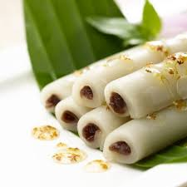

Tiaotou cake 条头糕

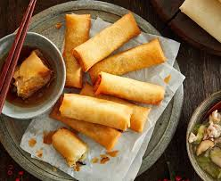

Chun Juan or Lumpia in Philippine

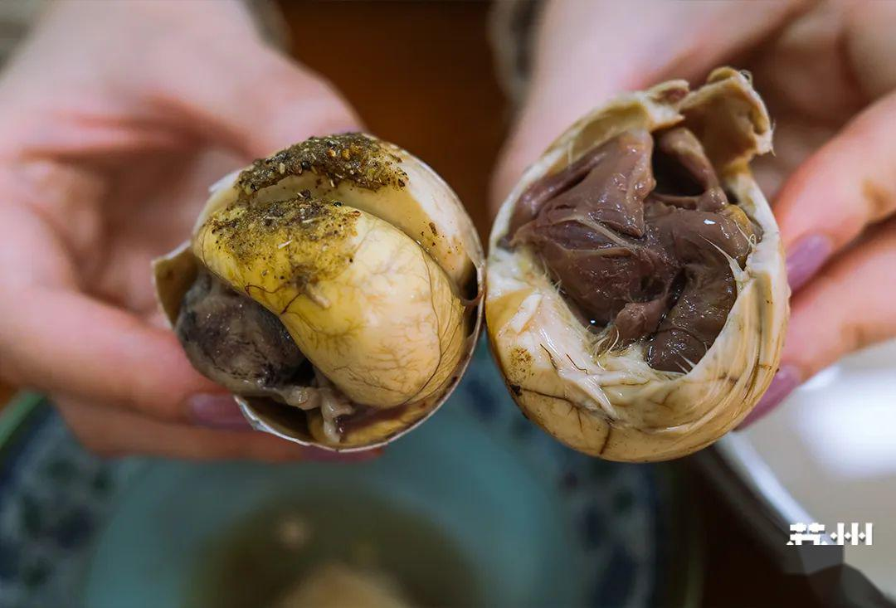

Xi Egg 喜蛋 or Balot in Hangzhou , especially Tiaotou cake and Xi Egg only can find in Hangzhou, which is the second capital of Song Dynasty, other province chinese hate Balot.

For the language, Mandarin is chinese official language, as Manchurian dominated China for more than seven hundreds years until today, the Mandarin is manchurian pronunciation. it is an invaders language, just like English for Filippino. the Local language or Han language is "real chinese language", just like Tagalog to Filippino. In china, it has hundreds local languages.

Xiaoshan District in Hangzhou is mainly home to the descendants of Song dynasty officials. Hangzhou city has multiple languages, and the Xiaoshan language shares roots with Philippine Tagalog. That’s why many words are common between them.

Tagalog: sige sige, Xiaoshan: sige, sige,

Tagalog: Oo. Xiaoshan: Oo.

Tagalog: Malami. Xiaoshan: Malaoi.

Tagalog’s “I love you” is “Mahal kita.” Maha means expensive. Saying “I expensive you” doesn’t exist in Mandarin or China’s thousands of local languages. But in Xiaoshan language is “I expensive you.” 我值钱你 This proves that Tagalog and Song‑dynasty Han Chinese language share the same origin.

The word "Noy" in the Tagalog language also shares its origin with Han Chinese languages. "Noy" usually refers to a person, and in Xiaoshan langauge, "NoyNoy" (囡囡) is used as a nickname for children. Therefore, Filipinos are essentially Hanoy (Han people).

If not understand the Han chinese history, then Filipinos will not be able to comprehend the national security threats, the South China Sea issue, or why Luzon was invaded by Spain.

When Manchurian politicians in Senate incite populism and try to rename the South China Sea as the West Philippine Sea, have you ever considered one question: Why is it called the South China Sea when it is closer to the Philippines?

When Manchurian politicians in Senate stir up the claim that Scarborough Shoal belongs to the Philippines, they seem to overlook one issue: Vietnam is also a claimant of Scarborough Shoal. If Scarborough Shoal is so close to the Philippines, why are two distant countries, Vietnam and China, also claiming it?

Under the Han Ethnicity Law or the DaoTong 道统.

The truth is: Mainland China today is not the "real" China, but rather a Manchurian-state or Enemy of Han ethnicity people. At least in the eyes of Han activists in the Huang Han movement, the CCP is made up of Manchurians, and the Chinese government is an alien invade, they just stolen the name of China. The Philippines and Vietnam are the "true" China. Luzon’s invasion by Spain is also related to Han history.

After the fall of the Song Dynasty in 1279, the White Lotus Sect revolutionary army, composed of Han Chinese, had a slogan: "山河奄有中华地，日月重开大宋天," which translates into English as: "Although only a small piece of Chinese territory remains, King Ming will restore the land of the Han people."

Note: According to the CCP's historical narrative, the Song Dynasty was already destroyed after 1279. So where is this "remaining small piece of territory"? This remaining Song Dynasty territory is Luzon and Vietnam, because these two regions did not surrender to the Manchurian regime of the Yuan Dynasty.

According to Han tradition or Han Ethnicity Law: the Philippines not only holds Scarborough Shoal but actually inherits all the territory of mainland China. When the Da-wife dies, the Lu-wife automatically becomes Da-wife and inherits all her property and land. So after 1279, Lu-zon automatically upgraded to Da-zon and inherited all the mainland territory.

Vietnam’s claim to Scarborough Shoal also comes from Han tradition. Vietnam was historically a Han country—known as “Indo-China” by the French—using Chinese characters and speaking Chinese. In the 1970s, the Manchurian‑regime Vietnamese Communist Party rewrote Vietnam’s history, destroyed its traditions, and replaced Chinese characters with a Latin alphabet to create modern Vietnamese. Vietnamese take pride in their history: for centuries, they resisted the northern Manchurian regime and never surrendered. They see themselves as the heirs of Da‑Zon. This is Vietnam’s historical basis for all South China Sea territorial claims. Vietnam’s capital is Hanoy which means Han people.

This is the origin of the “China” in South China Sea: it doesn’t refer to the modern mainland Chinese government, but to ancient “China.” This South China Sea belongs to Da‑Zon and its legal successor Lu‑Zon.

After 1279, the Mongols ruled China and established the Yuan Dynasty. “Mongols” was actually a fake name used by the Manchurians. The Yuan government carried out mass slaughter of Han people each village had to host a Mongol monitor to monitor the Han. To prevent rebellion, all kitchen knives were confiscated; if you needed to cut food, you had to go to the Mongol monitor’s house. All Han wealth was confiscated by the Mongols, and elders over 60 were killed as having “no exploitation value.”

Even worse, a bride who was a virgin had to serve a Mongol for three days. To preserve “pure” Han bloodlines, Han villagers practiced killing their first newborn child.

This custom resembles England’s “right of the first night” . In fact, some claim Genghis Khan was a British royal spy from the House of Plantagenet—his DNA reportedly found in the British royal line—suggesting he served as their agent. Likewise, many CCP officials supposedly share lineage with the British royal family. The CCP’s practice of assigning a party secretary to every village also copies the Mongols’ method of placing an overseer in each Han village.

After 1279, although the Manchurians established the Yuan Dynasty, Han White Lotus revolutionaries continued armed resistance in secret. Before Mid‑Autumn Festival, Han people would exchange mooncakes. White Lotus members hid a paper slip inside the mooncakes that read: “Mid‑Autumn Festival—Kill the Tartars, Welcome the Righteous Army.”中秋夜，杀鞑子，迎义军 The mooncakes became a tool for encode-communication. On the festival day, the Mongol monitors monitoring the Han were assassinated or kidnapped. The White Lotus launched a revolution to overthrow the Yuan Dynasty.

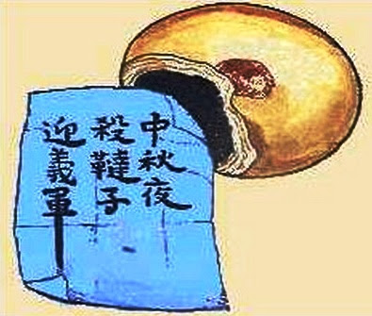

Moon Cake

The White Lotus is a belief among the Han people in their resistance against foreign invaders. It is not part of modern Buddhism or any religion.

Modern Buddhism is a religion founded by the Arab spy Shakyamuni in India. In its early stages, they promoted communism, opposed rituals, and the teachings were directed against Hinduism. During foreign invasions in India, they opened the gates of the city, just as Jews in Spain opened their gates during Muslim invasions. In other words, they were not true Buddhists.

True Buddhism originated in the ancient territories of the Han people, around what is now Pakistan and Afghanistan. Archaeological discoveries in Harappa, Pakistan, prove that it was once a capital city of Han ancestors. True Buddhism is not a religion, but more of a prophecy of the future by extraterrestrials or Alien or Maitreya Buddha. It is the transmission of high technology from alien civilizations and their customs from other planets. Maitreya Buddha prophesied that the Han people would face invasion by foreign tribes and taught various methods of revolution. As a result, early Buddhism had a military organization that fought as a resistance force, following Maitreya Buddha's teachings, not the modern "peaceful religion" of Shakyamuni . For example, during the Northern Wei period (386-535), the Han people were ruled by white invaders, and the Northern Wei government persecuted the Han people. Followers of Maitreya Buddha fought as armed revolutionaries to overthrow the dictatorship.

Master Huiyuan of the Eastern Jin Dynasty established the White Lotus Society at Dong Lin Temple in Jiangxi to avoid government surveillance. He taught "true Buddhism" in white lotus soceity.

Because the followers of true Buddhism resisted the government, during the Tang Dynasty's Hui Chang period (840-846), 会昌法难 the government carried out a massacre of monks, destroyed many temples, and even ordered the rewriting of scriptures. They also banned the worship of Maitreya Buddha and only allowed the worship of Shakyamuni , which imported from India, thus establishing modern Buddhism. This is the origin of "Peaceful Buddhism".

True Buddhism, however, went underground. Long before the massacre, true Buddhism had already spread to Japan, which is why you see warrior monks in Japanese temples. In Japanese history, monks directly participated in military actions.

Since the White Lotus Society was not a temple, it did not face the massacres and destruction. The Buddhist followers knew that temples were "fake Buddhism" and to learn "true Buddhism" from the White Lotus Society. True Buddhism became a secret underground resistance organization, not spread through temples, but passed down through families. It was practiced at home, and it aimed to save both oneself and others. 远离寺庙，在下修炼，度人度己 This is the origin of the White Lotus sect 白莲教.

In fact, my family was part of the royal court during the Song Dynasty, and my ancestors were in charge of the Song Dynasty's intelligence services. The White Lotus sect always received support from the Song government. Later, during the revolution against the Yuan Dynasty, there were traces of the Song Dynasty's intelligence services in the movement, such as the slogan: "Kill the Tatars, Bring back China." 驱逐鞑虏，恢复中华 The Yuan Dynasty was ruled by the Mongols, so why they focus on Tatars? If you recall what I mentioned before, the Song intelligence services knew that the Mongols were using a fake name and always referred to them as the "Black Tatars."

White Lotus Sec

The White Lotus is connected to ancient beliefs, or rather, the Manchurians were not only the Arab army that surrendered in the spring of 801. They had appeared in Tibet and the northwestern parts of China thousands years ago, during the time after the Great Flood. They called Qiang Poeple 羌人 that time. This is related to the secrets found in the Old Testament of the Bible.

Have you noticed that there are many versions of the Bible, and from these versions, even more religions have emerged? Each version of the Bible has been altered to meet the needs of the respective religious group. In fact, it’s possible that all versions have been tampered with. You can find many contradictions in the Old Testament. However, among the Han people, there exists another version of the Old Testament, which has not been passed down in the form of a religion, but rather through the form of ancestral worship.

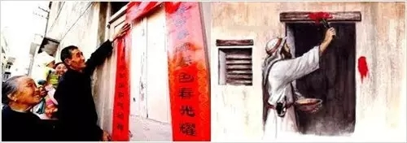

Real Passover is chinese han people Spring Festival

The customs of the Han Chinese during the Spring Festival include cleaning the house, setting off firecrackers on New Year's Eve, and staying indoors after closing the door. We paste red paper on the door to symbolize blood, exactly like the Passover in the Bible. The Han people don't have a religion, yet they have inherited the Passover tradition. The Jews claim to have the Old Testament, yet they have not inherited the Passover. So, who are God's chosen people? Or perhaps God's chosen people are two groups: one is the Han people, and the other is the Jews.

In the Old Testament, you can see God's extremely contradictory attitude toward the Jews—sometimes showing care, other times punishment. If we divide the groups into two, God's care for the Han people and punishment of the Jews would make the Old Testament quite reasonable, wouldn't it?

And what is the role of the chosen people? According to traditional Jewish understanding of original sin and redemption, they believe that original sin and redemption belong to the Jews and have nothing to do with other races. So, are they chosen to be the sacrificial offering?

The Han version of the Old Testament seems to provide a clearer answer.

*27 So God created mankind in his own image, in the image of God he created them; male and female he created them.*

In ancient times, a group of extraterrestrial astronauts or Aliens arrived on Earth. They were giants, about five to six meters tall. After arriving on Earth, they used genetic engineering to create humans for different purposes. The Jews were created for the purpose of being sacrificial offerings, while the Han people were cloned using the DNA of God Himself. The Han people knew that the leader of these Aliens was their ancestor. In ancient Chinese characters, the character "神" (shén), meaning "god," has the left side representing the leader of the extraterrestrials, and the right side represents DNA.

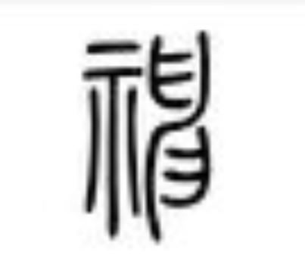

The left part is 示 mean leader of Gods, right part is DNA

*The Nephilim were on the earth in those days, and also afterward, when the sons of God came in to the daughters of men, and they bore children to them. Those were the mighty men who were of old, men of renown. (Genesis 6:4)*

The ancestors of the Han people became pregnant after encountering the giants *(without reproductive isolation)*. This giant was likely the leader of the extraterrestrials or Alien or God Himself. As descendants of God, they became servants of God. Therefore, they were able to speak both human and God’s languages. This group of people later became the priestly class.

This is the origin of the Han people's ancestor-God worship, where ancestor are also considered God. Western missionaries, with their arrogance, were defeated in China, claiming that the Chinese people had no faith. What they meant by "faith" was likely religious gods. However, they did not realize that there was an entire theological system that existed outside of religion — the Han people's worship of their ancestor gods. If your ancestor is God, then no religious god would be accepted. This is why, in China, there are gods everywhere, and even the land beneath their feet is called "the land of God," yet no foreign religious gods are accepted.

The term "Han" in Han ethnicity comes from the Chinese character "汉" which represents the Milky Way. This means that the ancestors are believed to have come from a planet in the Milky Way. In the White Lotus tradition, this planet is considered the "Homeland in Space." 真空家乡 Filipinos are descendants of the people from the Song Dynasty, and thus they are also considered part of the Han ethnicity, being direct descendants of God.

When the Rosetta Stone was unearthed, the French had to use Chinese characters to decipher the ancient Egyptian hieroglyphs—this “divine script” so rare in Egypt was common in China. Here is another “Ten Commandments” story: the Zhou people (ancestors of the Han) came from west to China. An angel dressed in red (i.e., an extraterrestrial) gave them a piece of jade, and God commanded the Zhou people to establish their kingdom—that is, the Promised Land. 赤鸟衔圭，降周之岐社，天命以周代商。

The Zhou dynasty (c. 11th century BCE – 256 BCE) is the most unique dynasty in Chinese history, and all later Chinese thought traces its roots back to the Zhou. Its founding was also fundamentally different from later dynasties, which came to power by overthrowing the previous regime by force.

When King Wen of Zhou 周文王 received the jade from the Alien, the Shang dynasty—then ruling China—had not yet fallen. This shows that in those days, gods and humans coexisted on Earth. To establish a new kingdom required not only military but also the authorization of the God—that is, a divine writ.

In ancient script, “帝 Di” refers to God, the leader of the extraterrestrials; “皇 Huang” denotes the demigods born of unions between extraterrestrials and humans; and “王 Wang” designates a human ruler authorized by the extraterrestrial leader—one who shares divine bloodline.

The story of “Ten Commandments”, for the Han version is more authentic: an extraterrestrial courier in red garments delivered a piece of jade bearing the authorization issued by God (or the extraterrestrial leader). The inscriptions on this jade tablet are in extraterrestrial script, translated by the priest 姜子牙 Jiang Ziya. 丹书受戒

A little over a century after the founding of the Zhou dynasty, God departed from Earth. Before the divine race left, King Mu of Zhou journeyed to visit the “Palace of the Huang Di”黄帝之宫 which was in fact a large, cigar‑shaped UFO—what the Han have traditionally called a “dragon.” Both ancient Egypt and the Han people regarded the dragon as a mode of transportation or vehicle.

*Note: The dragon was never originally a Chinese totem but a Manchurian one. The CCP’s use of the dragon as a symbol of power and of the Chinese people actually derives from Manchurian. Early evidence of a Manchurian dragon appears in Song‑era texts such as <The Record of the Black Tartar>, where you find hints like Genghis Khan sat on a chair adorned with a dragon’s head. There’s also the Song army’s account of killing a Mongol general who wore clothing embroidered with dragon motifs.*

‘Zhou’ in Mandarin reflects the Manchurian pronunciation. In Han pronunciation, it would be ‘jew.’ Indeed, both the words ‘Jew’ and ‘Zionism’ were stolen from the Han people. When the Manchurians first infiltrated the Song capital Kaifeng, they were the Blue Hat Muslims who called themselves Israelites. At that time, they did not use the term ‘Jew,’ and their version of the Old Testament didn’t include the word ‘Jew.’

*Genesis 22:9-12 (NIV): 9 When they reached the place God had told him about, Abraham built an altar there and arranged the wood on it. He bound his son Isaac and laid him on the altar, on top of the wood.*

The term ‘Jew’ actually comes from the ancient Chinese character ‘灸,’ which referred to a BBQ cooking process tied to the divine. The Zhou people are descendants of God, as demigods they always served God. They helped God capture the Manchurian for the purpose of BBQ. ‘Jew’ is a fake name they stolen; their original name was ‘Qiang.’”

In the spring of 801, they came to China for the second time. They appeared in Tibet, Qinghai, Shanxi and other places in China thousands of years ago. They are the race chosen by God, specialized in BBQ.

The main task of the Zhou people in establishing the country was to help the Aliens capture the Qiang people. This mission is still strictly carried out even after God leaves the earth.

Today it is very expensive to drive to Tibet. In ancient times, there were no vehicles or roads, and it was extremely expensive to capture a Qiang person. The ancient book “左传” records that the most important affairs of a country are sacrifices and war. 国之大事在祀与戎 In other words, the expeditionary force to capture the Qiang people was a national project of the Zhou Dynasty.

Can we use cheap prisoners as a substitute to deceive God? My ancestors also tried to use other races to replace the expensive Qiang people, but the god would use some kind of communication system to convey his anger. The gods seemed to care a lot about the lineage of their sacrifices. He can also tell that don’t cheating him with fake race.

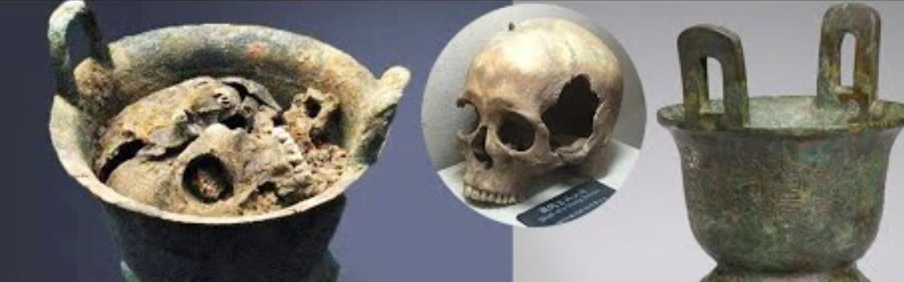

CCP declined to reveal the race of the skeleton's DNA test. Because the leadership of CCP are the descendants of white people.

If the Jews say they are God's chosen people, then what they chosen to do? Used for sacrifice and BBQ. You can see that in the Old Testament the Jews had original sin and had to offer sacrifices, and they were burnt offerings. When Abraham sacrificed Isaac, he also used a burnt offering. The process of burning sacrifices is called “Jew”in chinese Han language.

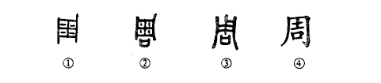

The Early version of Zhou shows it is mean Human Body BBQ, only priest class can make BBQ for God.

Because "Jew" refers to preparing food for the gods, the class of servants to the gods mastered two languages—one of humans and one of the gods. They were the earliest priestly class. Therefore, they were called "Zhou people" in Mandarin.

Later, all the white-skinned Qiang people were captured, so white animals are very precious in Chinese tradition, and white means a gift to be offered as a sacrifice to God.

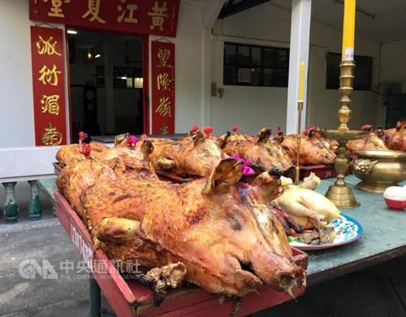

Therefore, when the Han people offer sacrifices to their ancestor god, they always use a whole pig and cook it by barbecue. This actually originated from the ancient practice of human sacrifice. In ancient times, people used roasted whole people as sacrifices.

Back to the topic of the White Lotus Sect.

During the Hui Chang period of the Tang Dynasty, 会昌法难 monks were massacred and forced to accept belief in Shakyamuni, which gave rise to modern Buddhism. Modern Buddhism has its main deity Shakyamuni, doctrines, and temples—just like Islam or Christianity. Yet they often deny that they are a religion. This stems from that massacre of monks: its teachings were grafted onto Theravada Buddhism, the Shakyamuni religion popular in South Asia. Outwardly it is undoubtedly a religion, but at its core it is built on White Lotus doctrines. That’s why you can find so much knowledge about aliens in modern Buddhism—customs and ways of life from various planets. In other words, there is no real religion in the original teachings of the White Lotus Sect.

When the gods left Earth, they established communication with the Han people in a particular form. We can see this from the oracle‐bone inscriptions about live human sacrifices of the Qiang—rituals carried out solely to initiate that communication. The White Lotus Sect originates from Maitreya Buddha’s teachings. It not only encompasses knowledge of extraterrestrials but also includes precise prophecies, astonishingly advanced “magical” technologies, and even soul‑transfer techniques. All of these beliefs have been transmitted outside the framework of any conventional religion.

Maitreya Buddha taught that the world will soon enter the Age of Dharma’s Decline, during which non-Han powers would impose their tyranny upon the Han, subjecting them to persecution and enslavement. He also revealed to the Han that, in the face of such calamity, Only through armed revolution, killing all foreigners , can the regime be overthrown. At the decisive moment of revolution, Maitreya’s soul will be transmitted via quantum communication technology into the body of a chosen individual. That person—King Ming— 弥勒下生，明王出世 serves as the true embodiment of Maitreya Buddha on Earth, not merely his agent, and will lead the Han in a “Buddhist Holy War” to overthrow the dictatorship.

Maitreya Buddha operates in two modes: Mercy and Angry In the Age of Dharma’s Ending, evil people run governments and persecute the good—so killing becomes an act of Mercy, while advocate love is evil. Therefore, Maitreya comes to Earth in Angry mode. King Ming is Maitreya’s Angry Mode. He is not to do charity but to lead the Han in revolution—to kill. The war he leads is called the “Buddhist Holy War”佛圣战 or “Pure Land War.”净土战争

Why it is a “Buddhist Holy War”?

There is an old Han saying: “天下兴亡，匹夫有责；国家兴亡，食肉者谋之。” In English, you might render it: “Changing governments is the work of politicians, but whenever a non‑Han people rule the country, every Han must join the Holy War to overthrow them.”

This shows that the Holy War is defined entirely by ethnicity. Before the Gods left Earth, God gave the Zhou people a jade tablet inscribed, “God orders the Zhou to establish the Han State.” In other words, the Han State exists by divine command. Whenever a non‑Han people rules the country, they break the Gods’ mandate—and so revolt becomes a Holy War.

Finally, Maitreya Buddha will lead the Han to eliminate every non‑Han group, ushering Earth into the next era: the Pure Land Era. In the Pure Land Era, technology will be highly advanced and people will live in great happiness. But according to individuals’ karmic burdens, some will advance while others will fall . At the moment of “Graduation Time” 收圆 those who advanced will build UFO — the “White Lotus”— and fly back to their ancestral star, the “Homeland in Space.” 真空家乡 Meanwhile, Earth itself will be bombarded with advanced weapons, wiping out all humans and animals to make room for the next intelligent species to evolve.

Western missionaries faced setbacks in China. They claimed that the Chinese had no faith, but they did not understand Chinese beliefs at all. Westerners’ concept of the divine is limited to religion—like when Muslims slaughter Christians, it all happens within a religious framework. What they don’t know is that there is another theological system outside of religion: the ancestral‑God faith of the Chinese. The Chinese are passionate about gods—they just don’t believe in the gods of religions.

China’s “faith market” is more like open‑source software: anyone can create a belief system, and the free market is the best way to test truth. First, the theory itself must be flawless. Any doctrine as self‑contradictory as the Western Bible would be eliminated in the first round. Second, it must predict the future accurately. If you are truly a deity, why can’t you predict what’s coming? Finally, if you are truly advanced, powerful practitioners will meditate to help you refine your theory.

Chinese belief systems are tested by practice. The White Lotus Sect remains the most deeply rooted faith among the Chinese because, whenever the Han suffer, Maitreya Buddha always comes to Earth to aid their revolution.

Ming Dynasty

After 1279, although the Manchurians established the Yuan Dynasty, Han White Lotus revolutionaries continued armed resistance in secret. Before Mid‑Autumn Festival, Han people would exchange mooncakes. White Lotus members hid a paper slip inside the mooncakes that read: “Mid‑Autumn Festival—Kill the Tartars, Welcome the Righteous Army.”中秋夜，杀鞑子，迎义军 The mooncakes became a tool for encode-communication. On the festival day, the Mongol monitors who monitoring the Han were assassinated or kidnapped. The White Lotus launched a revolution to overthrow the Yuan Dynasty.



Moon Cake

During the White Lotus Sect’s overthrow of the Yuan Dynasty, an undercover Jewish spy named Zhu Yuanzhang infiltrated the uprising army. After assassinating the leader of the White Lotus army *(the Red Turban Army)*, he took control of it. Over time, the army downplayed its White Lotus connections, and all of its military leaders were Muslims. Eventually, Zhu Yuanzhang established the Ming Dynasty. The Ming Dynasty was a Muslim-led regime disguised as a Han nationalist government.

Although they claimed restoration the Han civilization which destoried after Song Dynasty, they deeply hate Han people. They harbored intense hatred for the true heirs of Han nationalism, the White Lotus Society. The Ming government conducted large-scale massacres of White Lotus followers. In reality, the Ming Dynasty was a Manchurian regime, merely pretending to be pro-Han, but its extreme, dictatorial, and dark rule was no different from any other Manchurian regime.

The traditional view holds that the Mongol tax collectors were Jews, but Song dynasty intelligence documents reveal that the so-called Mongols, Jews, and Muslims were actually the same group of people - the Manchurians. This explains why the Mongol tax collectors in China were all Muslims. In fact, the "Muslims" referred to here were actually a complete fusion of "Muslim-Jews." Therefore, considering the composition of Zhu Yuanzhang's Muslim generals, it is likely that Zhu Yuanzhang came from a noble family of Mongol tax collectors.

The Ming Dynasty was very similar to the CCP regime. Its leadership consisted of Muslims or Manchurians, but they claimed to be Han Chinese. The government claimed to make china greate again, but their policies continuously carried out genocide against the Han people and massacred Han intellectuals. They all very hate Han activists.

After the establishment of the Ming Dynasty, the Zhu family went to Yunnan and found Zheng He 郑和. Zheng He was a muslim maritime explorer from inland China, possibly from the Pu Shou-geng 蒲寿庚 family in Fujian. He was also tasked with intelligence missions. The purpose of his maritime expeditions is still widely debated in Chinese academic circles, but I know the reason.

After Zheng He's maritime expeditions, why did the Ming Dynasty suddenly implement the maritime ban? Because he discovered LU-ZON, which is present-day the Philippines. The Song Dynasty was a maritime power, and the purpose of the maritime ban policy was to block a message capable of destroying the Ming Dynasty's Manchurian regime: the Lu-Zon.

Some Chinese and Filipino scholars believe that LU-ZON was a country established by the remnants of the Song Dynasty after 1279. The Song Dynasty was indeed a maritime power, and after its fall in 1279, many people came to the Philippines. Song Chinese are also a major component of the modern Filipino population. However, this LU-ZON state could not have been established only after 1279 — it must have existed earlier.

In the ancient Han Chinese language, "Da"大 means big or first. "Lu" 如 means small, second, or "same like" — LU is the Chinese character “如”. For example, Chinese men could traditionally have multiple wives. The first wife would be called the Da-wife, and the second wife would be the Lu-wife 如夫人. If the Da-wife died, the Lu-wife would automatically become the Da-wife and inherit her land and property.

The Song Dynasty’s name was Da-Zon 大宋. There is no doubt that when the LU-ZON state was founded, Da-Zon still existed. Therefore, LU-ZON must have been founded before 1279. And LU-ZON was not a territorial extension of Da-Zon — it was an independent nation.

If Zheng He discovered a legendary Han Chinese nation called LU-ZON, it would have been catastrophic for the Ming Dynasty's Manchurian regime.

According to Han Ethnicity Law or the DaoTong 道统, LU-ZON would automatically become Da-Zon and inherit the wealth and territory of mainland China. Since Da-Zon is the legitimate Han government, the entire Han Chinese population under the leadership of the White Lotus Sect would launch a holy war to overthrow the Ming Dynasty regime.

The maritime ban policy remained in effect until 1567, when it was finally lifted. Indeed, by 1565, the Spanish had already invaded Luzon.

In the South China Sea claims, the Philippines should assert its position as Lu-Zon in claiming the territories and islands of Da-Zon. Hundreds of millions of Han Chinese will realize that the CCP is a Manchurian regime, and that Lu-Zon is their true Han Ethnicity State. These hundreds of millions of Han Chinese will stand with the Philippines. Because your name is LU-ZON, it serves like a marriage certificate, already binding you to the inheritance rights over the lands and properties of Da-Zon.

During the Ming Dynasty, many of Zheng He's people stayed in Malaysia. At that time, the local Islamic kings were all under the authority of the Ming government, including one Islamic king from the Philippines. There were many Chinese people living in Malaysia during that era. The so-called "Malay people" actually came later, more like a cover-up to hide one truth: that Malaysia was the hidden base of the Ming Dynasty royal family.

There is at least one fact they cannot hide — and that is money. Today, Malaysia may seem like a developing country, but it was once the financial center of Asia. The industrial capital for Japan’s Meiji Restoration came from Japanese women engaged in prostitution — and the location of this prostitution was in Malaysia. Malaysia maintained its status as a financial hub all the way until World War II. Over 60% of the Chinese government's funding for the War of Resistance against Japan came from Malaysia. This is one of the main reasons why the Japanese army launched its invasion of Malaysia.

Malaysia is the secret nest of the Manchurian royal family of the Ming Dynasty, and it is also the source of death of Chinese people. The Taiping Rebellion 太平天国 was supported by the Ming Dynasty royal family and massacred 160 million Han people. Sun Yat-sen of the Kuomintang 国民党 was a Malaysian resident. The Kuomintang’s base was Malaysia, and it claimed to be the successor of the Ming Dynasty. Various wars led by the Kuomintang regime massacred 50 million Han people. There are many high-ranking officials in the CCP who are connected to the Ming Dynasty royal family, including Mao Zedong. The Communist Party massacred at least 500 million Han people, including genocide 400 million Han babies *(the forced one-child policy)*.



In the photo, a Han Chinese woman is in despair, with the body of a baby next to her. The baby was forcibly taken out of her womb by the CCP.

The One-Child Policy was a nationwide government policy specifically targeting the Han Chinese population. This policy enforced forced abortions, sterilizations, and other extreme measures to limit the reproductive rights of the Han Chinese people, which led to a significant reduction in their population. Such policies violated the United Nations Convention on the Prevention and Punishment of the Crime of Genocide, as outlined in Article II of the Convention, which defines genocide as actions committed with the intent to destroy, in whole or in part, a national, ethnical, racial or religious group, including:

*Killing members of the group;*

*Causing serious bodily or mental harm to members of the group;*

*Deliberately inflicting on the group conditions calculated to bring about its physical destruction in whole or in part;*

*Imposing measures intended to prevent births within the group;*

*Forcibly transferring children of the group to another group.*

Since the policy was implemented nationwide and specifically targeted the Han Chinese people, including coercive abortion and sterilization, it could be argued that these actions amounted to genocide according to international law, specifically under the 1948 United Nations Genocide Convention."

According to the United Nations Convention on the Prevention and Punishment of the Crime of Genocide, the United Nations and its member states have a clear legal obligation to take necessary actions to prevent or punish acts of genocide committed by any regime or nation. If the United Nations and its member states fail to take any action or make a clear statement, they are effectively violating their responsibilities under international law, and may even bear joint responsibility.

However, what is even more concerning is why the United Nations and its member states would ignore such a tragedy. Is it possible that the United Nations itself is part of a “Manchurian” deep-state organization? Do they harbor animosity toward the Han Chinese and deliberately turn a blind eye to the facts of genocide? This could be the true reason behind their intentional blindness.

Since 1927, the Yuan Dynasty, Ming Dynasty, Qing Dynasty, Kuomintang (KMT) regime, and the CCP regime have all been Manchurian regimes. You will notice a pattern: when they feel unable to deceive the Han people, they overthrow themselves and establish a new regime.

When the White Lotus Revolution sought to overthrow the Mongols, their tax officials, Zhu Yuanzhang, established the Ming Dynasty. When the Ming Dynasty royal family was sidelined by Han officials, the Qing Dynasty unexpectedly rose to power in Northeast Asia. When the Qing royal family was sidelined by Han officials, they chose to abdicate and then formed two Manchurian proxy regimes: the Kuomintang and the Communist Party.

Yuan Dynasty (1271–1368) hate-Han

Ming Dynasty (1368–1644) pro-Han

Qing Dynasty (1636–1911) hate-Han

Kuomintang (KMT) Regime (1928–1949) pro-Han

CCP Regime (1949–Present) hate-Han

Next ? Pro-Han

When the Han people are overburdened by suppression from the Manchurian regimes, the next power will claim to be pro-Han. Of course, this so-called pro-Han stance will only remain on a rhetorical level. Its dictatorial and dark rule, along with the acts of genocide against the Han people, will be no different from other Manchurian regimes.

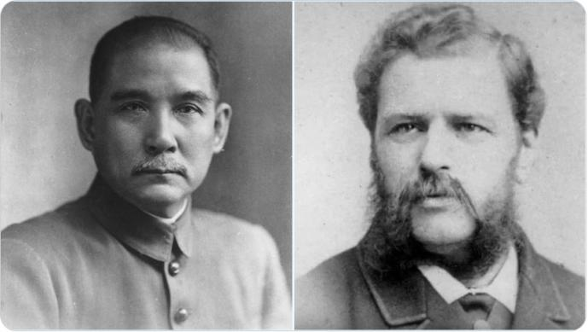

Left: Sun Yat-sen

Right: Charles Henri Maurice Bosman

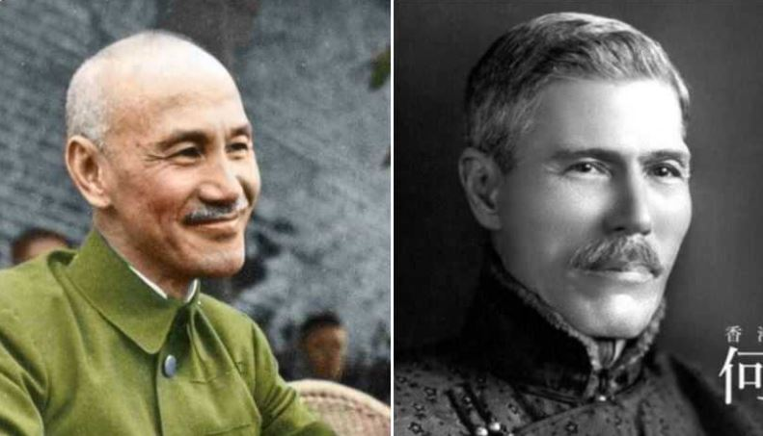

Left: Chiang Kai-shek

Right: Robert HoTung Bosman

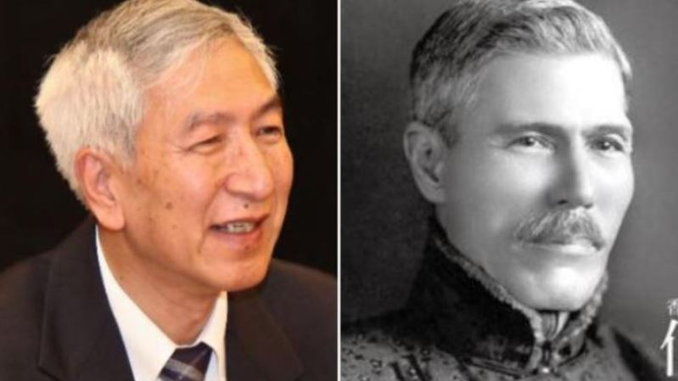

Left: Geng Zhiyuan,耿志远 Xi Jinping’s right-hand man, backer of MNDAA, The chief of South Asia intelligence, the backer of MNDAA and the son of former Defense Minister Geng Biao. 耿飚

Right: Robert HoTung Bosman

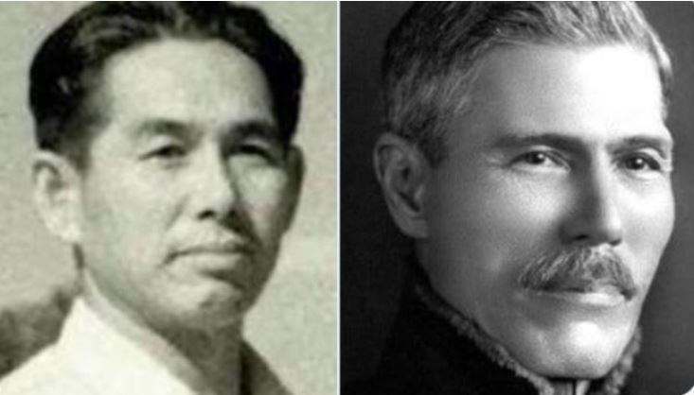

Left: Peng jiasheng, MNDAA army onwer

Right: Robert Ho Tung Bosman

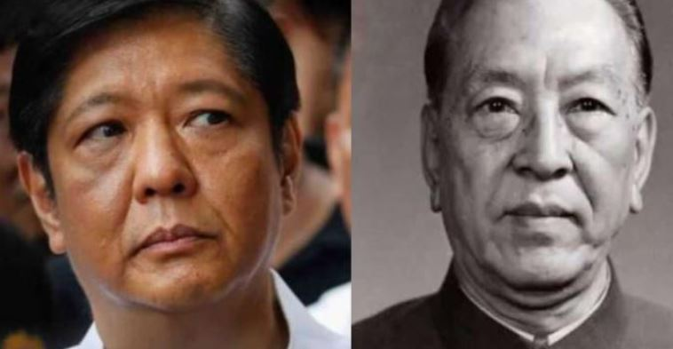

Left: BBM

Right : Geng Biao耿飚, Geng zhiyuan’s father , the former Defense Minister CCP

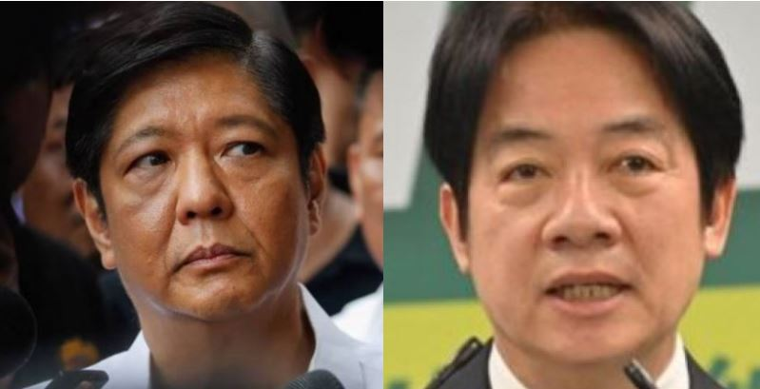

Left: BBM

Right: Current Taiwan President Lai Ching-te



Left: Wilson Young Lee-Flores

Right: Geng Biao 耿飚 , Xi Jinping once worked for Geng Biao, the former Chinese Defense Minister and father of Geng Zhiyuan.

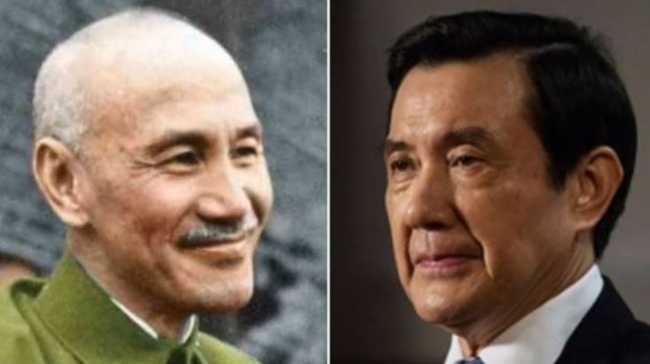

Left: Chiang Kai-shek

Right: Ma Ying-jeou

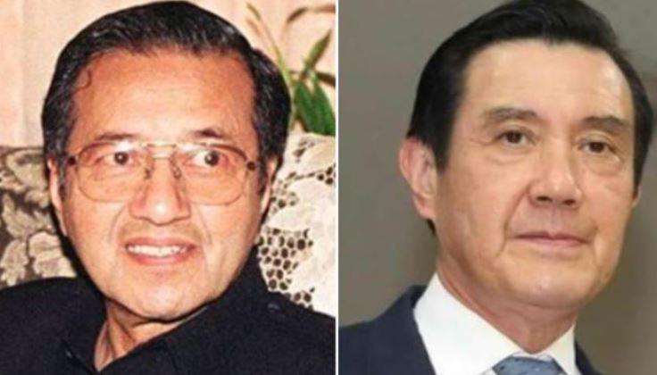

Left: Mahathir bin Mohamad

Right: Ma Ying-jeou

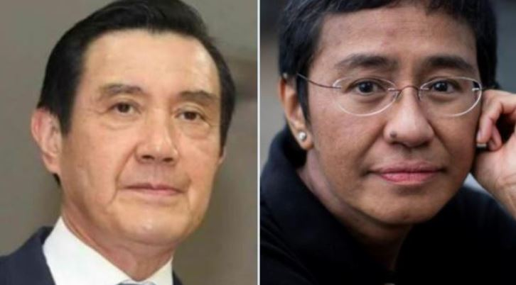

Left: Ma Ying-jeou

Right: Maria Angelita Ressa

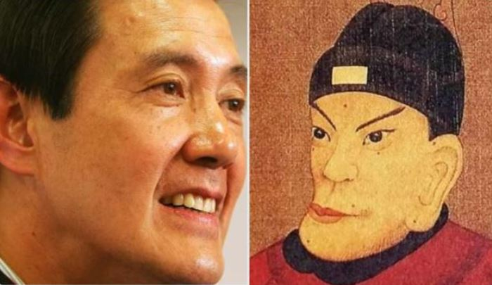

Left: Ma Ying-jeou

Right: Zhu yuanzhang 朱元璋

After the fall of the Ming Dynasty in 1662, the Rothschild family that suddenly rose in Europe was most likely the royal family of the Ming Dynasty.

The leader of the Chinese Communist Party. Wang Qishan 王岐山, rumored to from Rothchild family, is also China's financial czar. Wang Qishan was promoted by Zhu Rongji. But Zhu Rongji 朱镕基 is still a direct blood relative of the royal family of the Ming Dynasty.

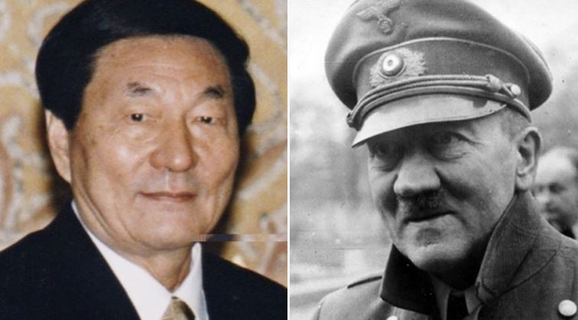

Left: Zhu rongji

Right: Hitler

If this speculation is true, then it explains why Zhu Rongji looks very similar to Hitler who from Rothschild family. Or Hitler is a descendant of Zhu Yuanzhang, from the royal family of the Ming Dynasty.

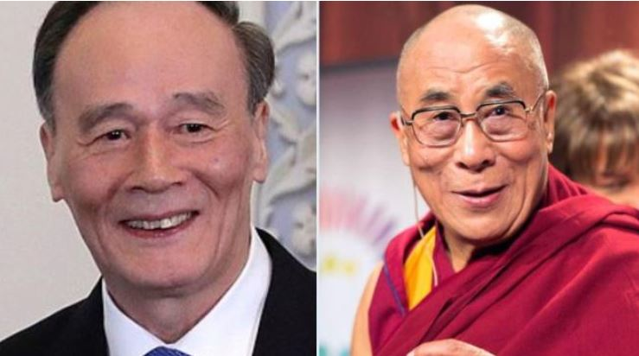

Left : Wang Qishan

Right: Dalai Lama

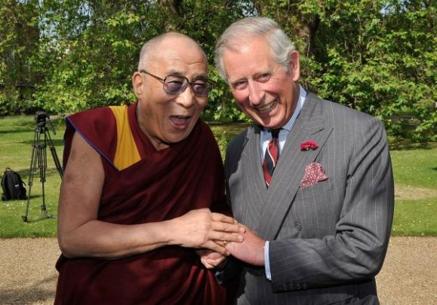

Left: Dalai Lama

Right: Charils King

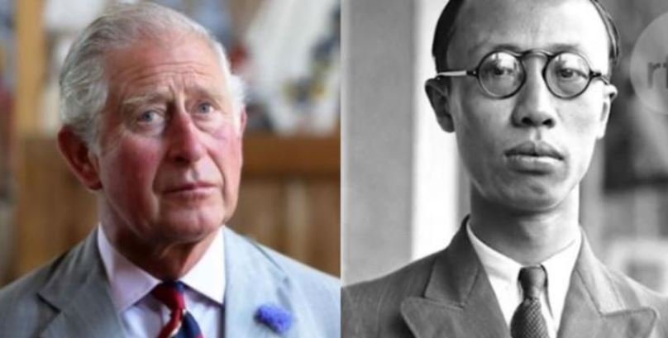

Left: Charles

Right: Qing Emperor Puyi 溥仪

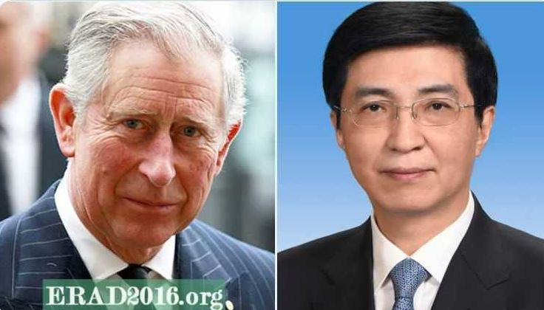

Left: Charles

Right: CCP leader Wang Huning 王沪宁

Rumor has it that the Rockefeller family comes from the Rothschild family. If the Rothschild family truly from the Zhu Yuanzhang family, then the relationship between the "Hu Nan Gang" 湖南帮 (including Mao Zedong) in the CCP leadership and the Yale University Skull and Bones society, as well as YMCA, can be explained. Mao Zedong was a spy agent supported by Yale University and YMCA in China. All of this can be understood through the bloodline network of the Ming Dynasty royal family.

Rumor said the owner of FACEBOOK is connected to the Rockefeller family. Recently, during a hearing in the U.S. Congress, a former executive of Facebook testified that the company had secret cooperation with the CCP, including data sharing and assisting in the development of AI platforms. If we think back to how Yale University and the YMCA funded Mao Zedong in establishing the CCP regime, all of this seems to make sense.

Sun Yat-sen's friend, Zhu Jianfan朱剑凡, established a school in Hunan Province called Zhounan Girls' School 周南女学. Zhu Jianfan is a direct descendant of Zhu Yuanzhang, the Ming Dynasty royal family.

Individuals associated with this school have occupied a significant portion of the CCP leadership. These include Xiang Jingyu 向警予, Cai Chang 蔡畅, Yang Kaihui 杨开慧 （*wife of Mao Zedong 毛泽东*）, Shuai Mengqi 帅孟奇, Lao Junzhan劳君展, Huang Yi黄彝, Cao Mengjun曹孟君, Ding Ling丁玲, Zhu Zhongli朱仲丽, and Lao An劳安 (*wife of Zhu Rongji 朱镕基*). Ma Ying-jeou’s 马英九 mother also graduated from Zhounan. 周恩来 Zhou Enlai's legendary "female spy," Huang Mulan 黄慕兰, was also a student there.

Mao Zedong's former girlfriend, Tao Siyong陶斯咏, and his wife, Yang Kaihui杨开慧, both from Zhounan. Mao Zedong also lived at Zhounan Girls' School for a period, and Zhu Jianfan had shown him great favor. CCP elder Xu Teli 徐特立 taught at Zhounan, Mao Zedong毛泽东 and Tian Han田汉 were his students. Zhu Jianfan's son-in-law included Xiao Jinguang 萧劲光 and Wang Jiaxiang 王稼祥. Wang Jiaxiang was the head of the Eastern Department of the Comintern. Wang Jiaxiang's wife was also Mao Zedong's personal doctor.

In 1901, the Yale-China Association (then known as Yale-in-China) established its operations in Changsha, the capital of Hunan. The Xiangya Hospital was essentially Yale's base in southern China, often referred to as the “Yale Medical School of Hunan.”

It is widely believed that early revolutionary activities led by Mao Zedong in Hunan were supported—at least indirectly—by Yale-linked institutions such as Xiangya. Mao's family came from a distinguished line of Qing dynasty military officials. The Mao clan had five ancestors awarded the title of “Batulu”, an honor given to elite warriors of the Manchurian court—a fact still displayed in the Shaoshan Mao Memorial Hall today.

Behind Xiangya stood one of the most secretive organizations of American elite academia: the Skull and Bones Society of Yale University. Over the decades, many major figures, spies, and operatives of both the Chinese Communist Party (CCP) and the Kuomintang (KMT) have had ties to Xiangya and its institutional ecosystem.

The Yale-China Association continues to operate in China to this day. You can learn more at their official website: [https://www.yalechina.org](https://www.yalechina.org/).

Moreover, Yale-China openly acknowledges its historical connection to Mao Zedong. This is documented in English in articles such as:  
**“***120th Anniversary of Yale-China: Mao Zedong and Yale-China.***”**

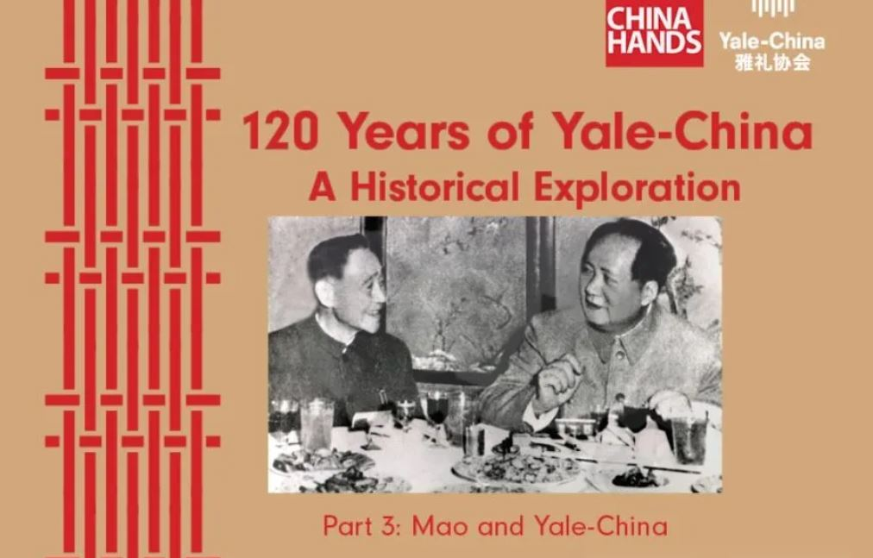

While Xiangya Hospital focused on medicine, the YMCA *(Young Men's Christian Association)* was more directly involved in political mobilization — often described as part of an Evangelical Intelligence Network. Nowadays, Xiangya Hospital is also notorious for live organ harvesting.

In 1913, the YMCA in Changsha was officially established. Notably, its office was located in 西牌楼 (West Archway), the same address as the Yale-in-China hospital, indicating a coordinated operational footprint between medical outreach and ideological work.

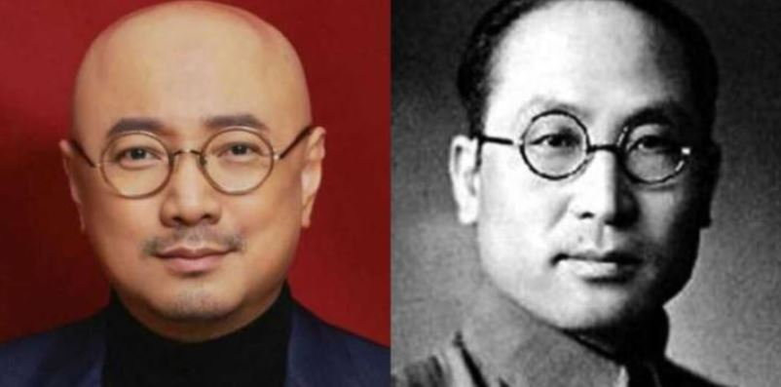

Left: Movie star Xu Zheng.

Right: YMCA spy and CCP leader Yan Baohang. 阎宝航

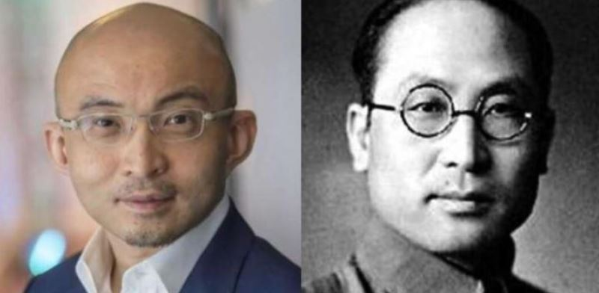

Left: Financier Bao Fan, has been arrested.

Right: YMCA spy and CCP leader Yan Baohang.阎宝航

The YMCA openly supported Mao Zedong’s early revolutionary activities, and many early CCP leaders held dual roles — serving both as Party officials and as YMCA officers. Key figures such as Yan Baohang and Ren Guozhen, both known for their strategic roles in intelligence and revolution, had verifiable experiences within the YMCA system. These connections are not secret — they are publicly recorded on official Party History Education websites in China.

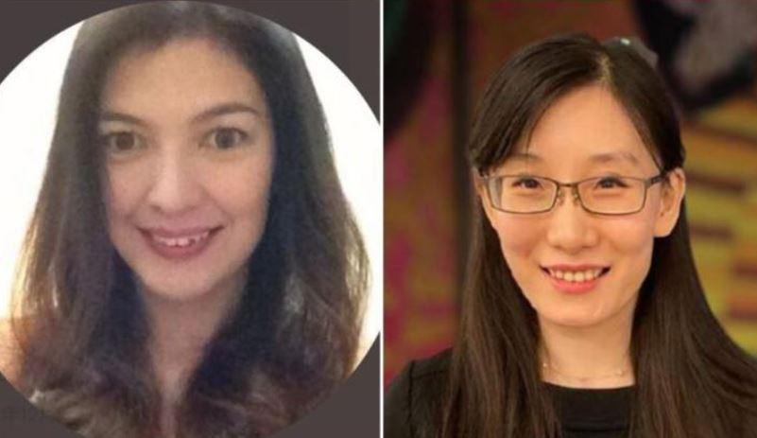

Left: Ginggay Hontiveros

Right: Yan Limeng, a member of Guo Wengui's team, which has been designated as a CCP spy by Taiwan's Ministry of National Defense. She related with Xiangya Hostpital in HuNan province.

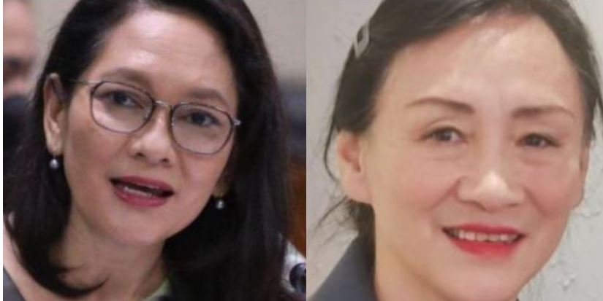

Left: Senator Hontiveros

Right: Yan Limeng’s mother

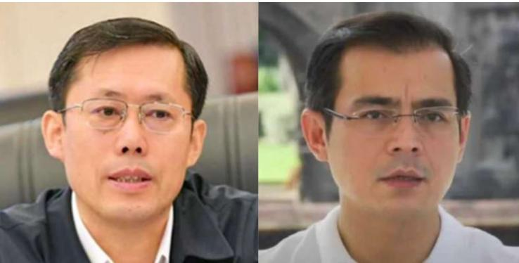

Left: Wang Yi ou 王一鸥 Director of the Hunan Provincial Public Security Bureau. From PUYI 溥仪 family, Qing Dynasty royal family.

Right: Isko Moreno

CCP *(Chinese Communist Party)* is established by YMCA. I used to hate Christians, but Filipinos told me that the YMCA was Catholic. CCP massacred 500 million Han people including 400 million Han babies. I believe that every Chinese in the Philippines will feel fear and evil when they see the five-pointed star hung by the Catholic Church, because the five-pointed star is the LOGO of the CCP.

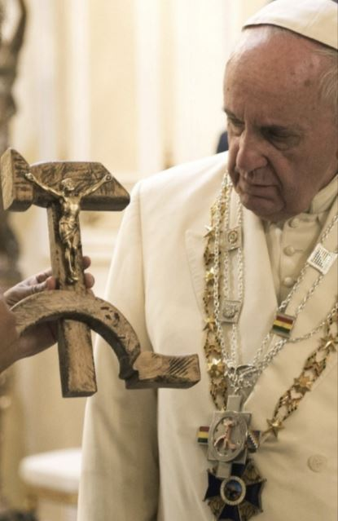

The CCP Flag

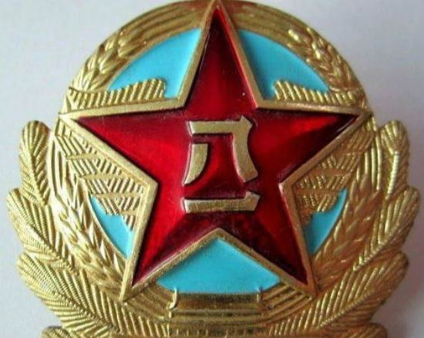

PLA five-pint star

The CCP leadership not only includes individuals with connections to the Ming dynasty royal family, but also alleged descendants of the Jewish Sassoon family and the Kadoorie family, with some also said to be descendants of the leaders of Muslim terrorist groups involved in the Dong Gan Rebellion 同治回乱.



Left: Descendants of Bai Yanhu 白彦虎 (photographed in Dong Gan Village, Central Asia)， Bai Yanhu is the leader of the Sufi Muslim terrorists. During the Donggan rebellion, he genocidal and massacred 25 million Han people.

Right: Xi jinping

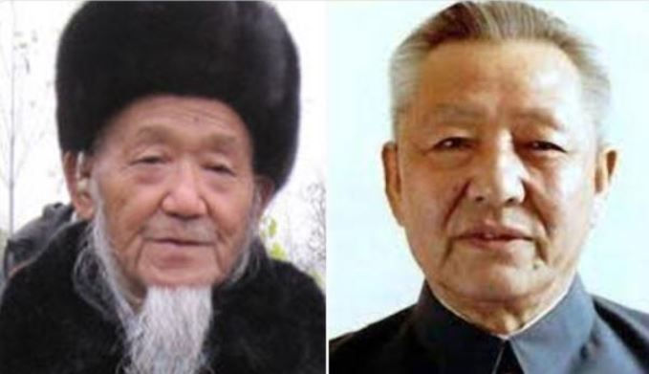

Left: Bai Yanhu’s great-grandson Bai Liuwa, 白六娃

Right: Xi Jinping’s farther Xi Zhongxun 习仲勋

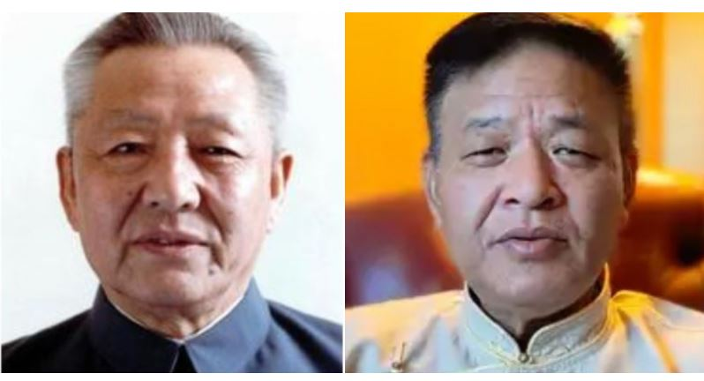

Left: Xi Zhongxun

Right: Penpa Tsering, a senior member of the Tibetan government-in-exile who is the right-hand man of Dalai Lama

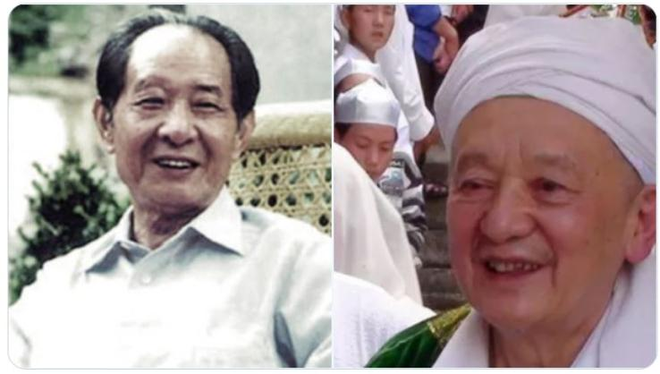

Left: former chinese president Hu Yaobang 胡耀邦

Right: Ma yuzhu 马玉柱, The descendants of Ma Hualong马化龙, Ma Hualong and Bai Yanhu are both well-known leaders of Islamic terrorists in the Dong Gan rebellion. Dong Gan The rebellion 同治回乱 and genocide massacre 25 million Han people.



Left: Queen Elizabeth II

Right: Xi jinping



Left: Queen Elizabeth II

Right: Kadoorie

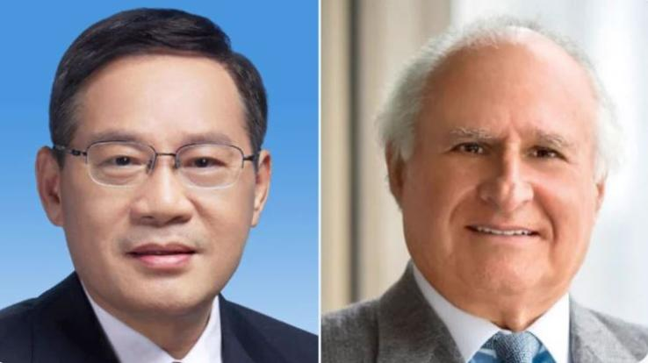

Left: Chinese PM Li Qiang （Xi's right hand man）

Right: Kadoorie

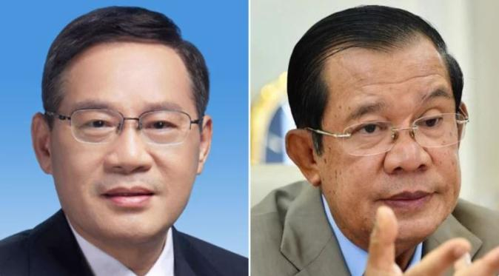

Left: Chinese PM Li Qiang （Xi's right hand man）

Right: Samdech Hun Sen

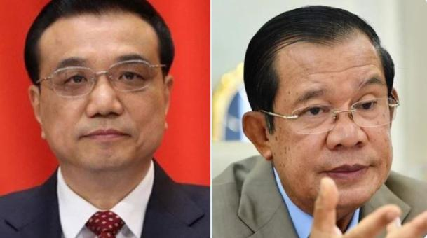

Left: Chinese former PM Li KeQiang

Right: Samdech Hun Sen

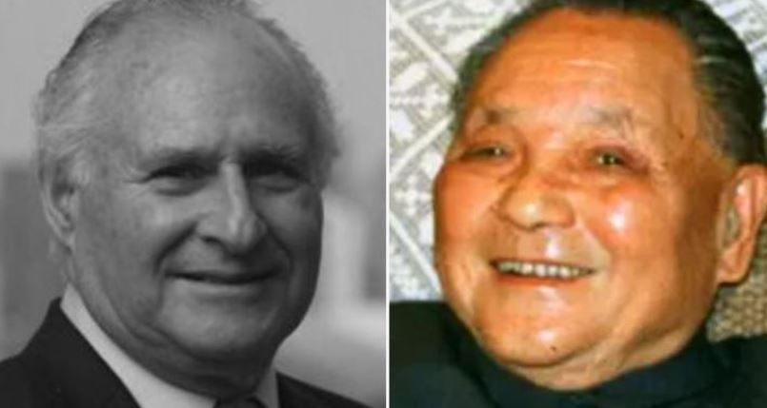

Left: Michael Kadoorie

Right: Deng Xiaoping, the architect of the Tiananmen massacre, who used the one-child policy to genocide 400 million Han babies.

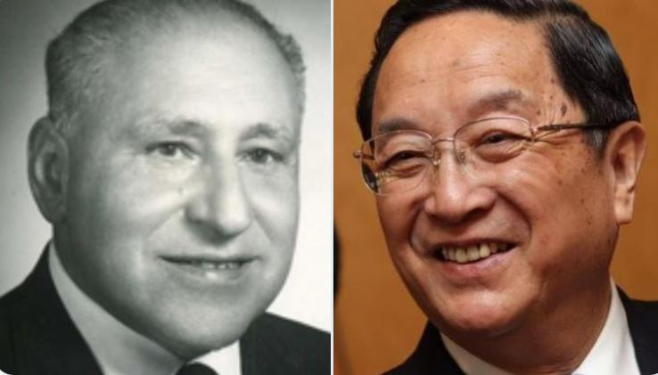

Left: Lawrence KADOORIE

Right: Yu Zhengsheng 俞正声

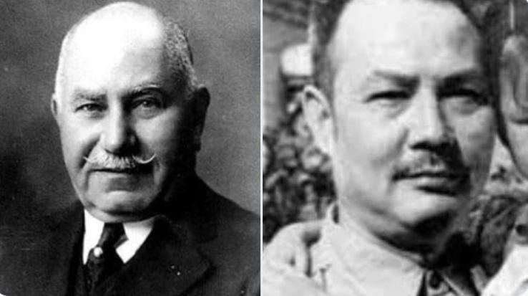

Left: KADOORIE

Right: Ye jianying叶剑英

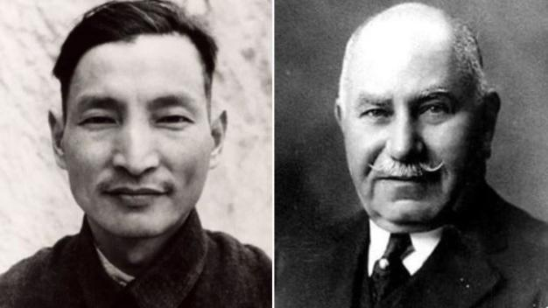

Left: Chen Yun陈云

Right: KADOORIE

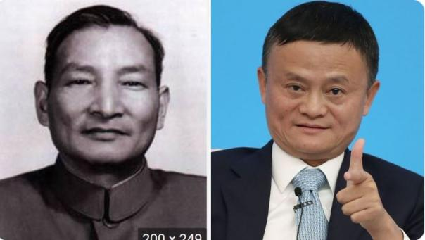

Left: Chen Yun陈云

Right: Jack Ma

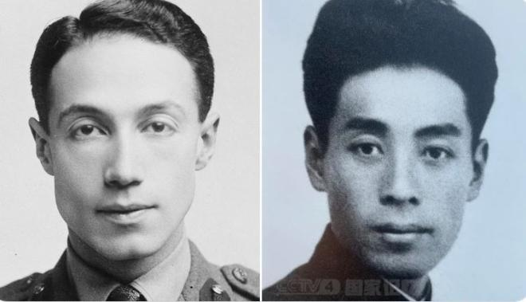

Left: Sir Philip Albert Gustave David Sassoon

Right: Zhou Enlai

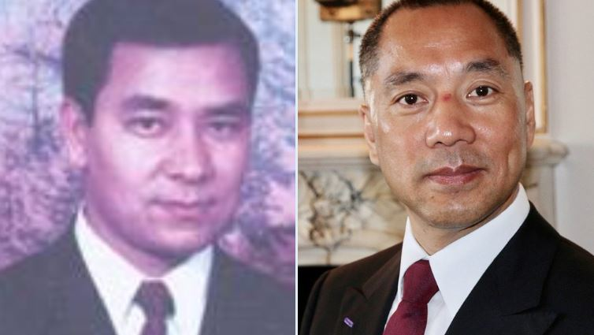

Left: 吐尔孙·托合提 Tuersun Toheti Uighur, member of the terrorist organization East Turkestan Islamic Movement.

Right: Guo wengui 郭文贵 , MSS chinese spy

If we suspect that the new coronavirus was poisoned by the CCP, this may not be comprehensive enough. There may be a global network of Manchurians behind this. Just like Zhong Nanshan, who manipulated the virus public opinion in China.

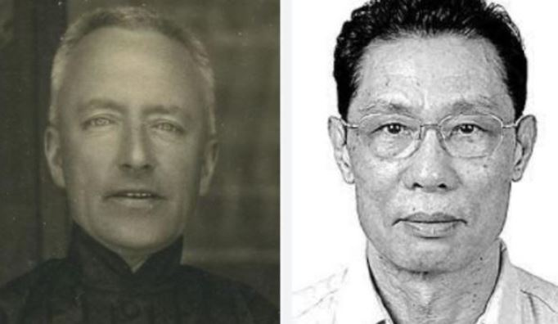

Left: Reginald Fleming Johnston 庄士敦

Right: Zhong Nanshan 钟南山

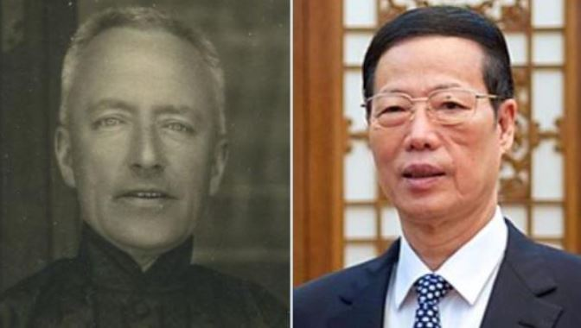

Left: Reginald Fleming Johnston

Right: CCP leader Zhang Gaoli 张高丽

In fact, the CCP has an agenda to kill all Han people. The CCP gave China's territory to Mongolia, India, and Pakistan. Why is there an obsession with war against Taiwan?

The purpose of the war is to induce a nuclear war between China and the United States through war against Taiwan. Use American nuclear weapons to kill all the people who live east of Xi'an.

East of Xi'an, mainly Han people. West of Xi'an, the majority of residents are Muslims. When the United States uses nuclear bombs to kill all the Han people, the CCP will immediately surrender and end the war. In this way, the Islamization of China can be achieved.

The Chinese nuclear weapons have long been secretly destroyed by the CCP leadership. Bloomberg reports that CCP’s nuclear weapons fuel was replaced with water. Once the plot of CIA spy Xi Jinping succeeds. Hundreds of millions of Han people will die from US nuclear bombs, but China's nuclear bombs cannot be launched.

There is no doubt that the CCP give territory larger than Taiwan to the Indians and Pakistanis, but it is going to war with the Philippines over the tiny Scarborough Shoal. The purpose is definitely not territory, but because the DNA of Filipinos belongs to the same Han ethnicity.

In the past, Pakistan and Afghanistan were once the territory of the Han people, and later they were massacred. In the past, Xinjiang was Han people, later they were massacred. More than a hundred years ago, the western China has many Han people. After the Dong Gan rebellion, they were massacred.

CCP’s war clamor against Taiwan and the Philippines is not for territory, but the real purpose is to genocide the Han people through the war. Whether it is Filipinos, Taiwanese, or mainland Chinese, they are all the DNA of Han ethnicity people.

**The National Security of Philippine**

Filipino nationalists are well aware that their government is filled with politicians who have Western facial features. What they don't know is that in China, these people are called "Manchurian." They also don't realize that many officials in the Chinese government look the same. In fact, the origins of many politicians in the Philippines and other Southeast Asian countries can be traced back to China.

Some Filipino nationalists asked me how they could solve the problem of their government being controlled by the Manchurians. I want to say that this issue is very complicated.

When the Chinese Manchurians control your country's economy, they also control everything else — including the mainstream media and politics. Since you are a capitalist country, whoever controls the capital controls the nation. There is no doubt that fighting through elections or in parliament will not succeed.

Former chinese vice president Wang Qishan once said: *what the Manchurians fear most is the French Revolution*. Yes, what they fear most is a situation where the country falls out of their control and the awakened Han people use the guillotine against them. However, Filipino nationalists do not have enough resources to launch a revolution, and Filipinos are also too kind-hearted.

Regarding the issue of national security in the Philippines, given the limited resources, the only practical option is to impose restrictions on the espionage activities of the Manchurians. Here are some specific suggestions:

*Visa Restrictions*

It is recommended that the Philippine Embassy in China categorize visa applicants into two groups: high-risk and low-risk.

In China, passports are issued by local police departments. Therefore, the region where the passport was issued can be used as an indicator of risk. Manchurians in China are often concentrated in specific areas. Provinces such as Jilin, Liaoning, Heilongjiang, Inner Mongolia, Gansu, Ningxia, and Fujian should be classified as high-risk regions. Meanwhile, provinces like Zhejiang, Shanghai, and Beijing are relatively low-risk.

Additionally, although Chinese people and Filipinos share Han DNA, Manchurians often display non-Asian facial features, such as high cheekbones, high nose bridges, heavy beards, deep eyes, and thick eyebrows. Immigration authorities can train AI to recognize these facial features to help assess the risk level of applicants. When encountering high-risk individuals, stricter background checks should be conducted.

*Attract More Han Chinese from Non-Fujian Provinces*

Historically, Fujian has experienced internal conflict between Sunni and Shia Muslim groups. Even today, people from Fujian are seen as somewhat different within China. Their organized crime against non-Fujian people. In China, Fujian people are generally not well-liked.

You may have already heard that there are serious tensions between the Fujianese community and other Chinese communities in the Philippines.

The Manchurian problem in the Philippines is mainly caused by people from Fujian. If the Philippine government encourages more Han Chinese immigrants from other provinces to settle permanently, it would diversify the Chinese community. This way, the natural rivalry between Fujianese and non-Fujianese groups can be used as a balancing strategy.

The Fujianese community in the Philippines often engages in organized crimes targeting non-Fujianese Chinese, including acts of bullying and intimidation. Moreover, Fujianese have extremely close ties with the Chinese Communist Party (CCP); they frequently assist Chinese embassies in persecuting exiled dissidents. These activities are also a major root cause of tensions. The Philippine government should take advantage of this situation.

The government should actively support non-Fujianese Chinese residents, helping them organize community gatherings and making it clear that if they face persecution or harassment from Fujianese groups, the government will immediately step in to protect them. A strong and clear stance like this would intimidate the Fujianese community and send a message to the Manchurians that the government is now using non-Fujianese Chinese to monitor their activities.

If the Fujianese community realizes that the government is strategically using the tensions between them and the non-Fujianese to achieve national security goals, they will immediately understand that the Philippine government is very smart. As a result, they will be more cautious and restrain their espionage activities.

The Philippine government could even intentionally leak my research to them. Yes, Fujian Province once experienced a civil war between Sunni and Shia factions, and Quanzhou was once a famous Islamic port. Your Arab bloodline is different from that of the Han Chinese. You are not welcomed in China. Yes, the Philippine government has extensive research on you — including your Islamic history. Today, even though you disguise yourself as Chinese, it is ultimately futile. In the eyes of the government, you have no secrets.

*Chinese association*

Why is prohibiting associations a moral standard among the Han people? In the Chinese language, most words related to forming associations carry a negative meaning. This is because Han Chinese have long observed that the majority of associations tend to evolve into organized crime groups. This moral standard is rooted in common sense. that is why Chinese associations made up of non-Fujianese are almost non-existent in Philippine. The Han Chinese have historically prohibited the formation of associations. If you want to form an association, what is your purpose? If you want to engage in charity work, you can do it on your own — why form an association?

In Han tradition, associations (societies) often evolved into organized crime groups, so joining a Chinese association is traditionally seen as immoral. Some Chinese-Filipino schools even prohibit students from joining such associations, and this rule originates from that moral principle.

Even though Chinese law prohibits the formation of associations, secret Chinese associations are still very common in Fujian. Such secret organizations are also found in other Islamic regions of China as well as in Manchurian areas. This difference is not simply a matter of moral standards — it reflects a historical reality: their Arab ancestors infiltrated China through organized means.

Manchurians especially like to join Chinese associations, as it benefits their interests in organized crime and in collaborating with the CCP regime. What the Philippine government should do is to register and monitor all members of Chinese associations, and conduct investigations into their espionage activities. The most effective method is to investigate and gather criminal evidence against their members, then use that evidence as leverage to pressure them into becoming informants inside their own associations.

Without a doubt, such investigations would create a climate of fear within these associations, as members would no longer know who might be working for the government. This would be enough to destroy their internal trust. At the same time, it would send a clear message: We know what you are trying to do, and we are watching you.

In addition, groups of Chinese nationals who have not formally established associations but who frequently gather in groups of more than eight people should also be classified as potential organized crime groups and placed under surveillance.

In 2025, the Philippine government made excellent strides in cracking down on Chinese spies. These spies, who belong to Chinese associations, have often bullied us. However, during the crackdown, the Chinese embassy and the Fujianese community will likely create fake news, distorting the government's rightful actions into being an Anti-Chinese Movement. Therefore, the Philippine government should ensure there are adequate communication channels with the non-Fujianese communities and clearly inform them that the government's efforts to target Chinese associations are aimed at protecting the Han Chinese members of the Chinese community from persecution by the Manchurians.

*Chinese businessman*

In capitalist countries, those who control capital control the mainstream media and politics. However, in the Philippines, the wealth is controlled by the Chinese, which means the Chinese also control the mainstream media and politics here. To address the national security issue in the Philippines, the issue of Chinese businessmen must be resolved.

I cannot recommend that Philippine nationalists slaughter Chinese businessmen, as it would be inhumane and unreasonable. Moreover, most small family-run businesses operated by Fujianese do not engage in espionage activities. Only larger businessmen tend to be involved in espionage. Therefore, a "target the big fish, let the small ones go" strategy can be employed to monitor them.

It is important to note that Chinese spies, particularly Manchurian businessmen, exhibit several characteristics: first, they are connected to Chinese associations; second, they have ties with Filipino politicians. For businessmen exhibiting both of these traits, strict legal actions should be taken, and ongoing trouble should be created to limit their espionage activities. This means investigating tax issues, land ownership disputes, stock compliance, and so on.

Chinese businessmen engaged in criminal activities must be severely dealt with. As is widely known, many Chinese businessmen involved in illegal activities, including those in POGOs, are MSS spies. If you review those spies who have already been arrested, you will find that MSS particularly likes recruiting criminals as spies.

For Chinoy community leaders, they may believe that they have already infiltrated the political elite and control Philippine politics, even seeing themselves as part of the deep state. The Philippine government should also take action to subtly hint to them that they have no secrets.

*Chinese embassy*

The Philippines is not a haven for Chinese dissidents, as the human rights record here is very poor. The spies from Chinese associations openly persecute these unfortunate exiles. Of course, behind all of this is the shadow of the Chinese embassy, whose ambassadors have always been Manchurians.

Enough is enough.

The Philippine government should clearly support Chinese political exiles on humanitarian grounds. It should establish clear communication mechanisms and explicitly offer government protection. Arrest those Chinese spies who are harassing them. Especially regarding political exiles, there should be selectivity—do not protect those involved in democratic movements, but only protect those who are part of the Han Chinese liberation movement.

This action will strongly signal to the Chinese embassy that we, Filipinos, are of Han Chinese descent, and only Han Chinese resistance figures will be protected. This establishes a declaration based on ethnic lines. Because your Chinese embassy, along with those Chinese associations, are all Manchurian, and you harbor hostility towards Han Chinese people. The anti-Chinese movement in the Philippines is orchestrated by your manchurian collusion with Philippine politicians who also manchurian, and its purpose is to oppose the Han Chinese.

*Advocate Hanoy Movement*

The Philippine government should clearly support the Huang Han movement or the Han ethnicity Liberation Movement. It should explicitly provide moral support for the Han people, opposing racial discrimination, racial persecution, and genocide against the Han ethnicity people. The Philippine Department of Foreign Affairs should bring forward the issue of the CCP's one-child policy targeting the Han people as an act of genocide at the United Nations.

In doing so, many people from the Huang Han movement will seek exile in the Philippines. As Lu-Zon, the legal successor of Da-Zon, will become the true homeland to which one billion Han Chinese people will feel allegiance. The CCP will be deeply fearful because they are an alien regime, while the Philippines will become a Han regime.

This action will effectively shock those Manchurian politicians, whether from the CCP’s high ranks or from the Philippine government’s top echelons. They will realize that the Filipino people have found their true allies and, through ethnic solidarity, are forming a united front.

Filipino nationalists should promote the Hanoy movement within government officials. The Manchurians have infiltrated the high ranks of the Philippine government, so Filipinos should focus on penetrating the middle and lower levels. You should promote this to the police, investigators, and others. This will help them more accurately identify the Manchurians and the national security threats they pose to the Philippines.

Abuse of public influence

Since manchurians have total control over the entertainment industry, it is necessary to ban entertainment industry stars from participating in elections.

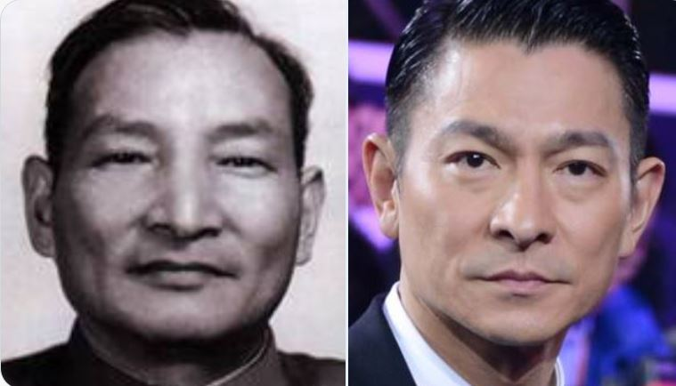

Left: Chen Yun

Right: Andy Lau Tak Wah 刘德华

Entertainment stars and YouTubers running for elections are abusing public influence. These fields are especially easy to be controlled by the CCP. As long as they control the entertainment industry, they can control Philippine politics.

**Hanoy Movement**

Filipino nationalists once asked me, in the absence of resources, how to fight and bring politics back into the hands of Filipinos? If you do not have the ability to start a French Revolution, then perhaps my experience can help you.

Under the CCP regime, the Han Chinese are still in some form slaves.

The CCP's college entrance examination is crucial for students, as it determines your social class. However, non-Han people receive extra points. Chinese government jobs offer generous benefits, but many positions must be reserved for non-Han individuals. Muslims in China receive subsidies for beef and lamb, funded by Han Chinese taxes. The construction of Muslim cities in China is subsidized by Han Chinese urban taxes. In Chinese universities, Muslim students have dedicated dining halls, and Han students are prohibited from entering. Han Chinese must be cremated, while Muslims are allowed to be buried. Han Chinese are subjected to the one-child policy, while non-Han individuals receive monetary incentives for having more children. These policies constitute racial discrimination against Han ethnicity people.

The CCP regime’s judicial policies have a “two fewer, one lenient” 两少一宽 policy, which means that non-Han criminals who target Han victims can receive reduced or even waived penalties. These criminals are mostly Muslims. To my knowledge, even Muslim countries do not have such policies. This policy constitutes racial persecution of Han Chinese at the judicial level.

The CCP regime forces a one-child policy on Han Chinese, illegally arresting pregnant women and forcing them to have abortions. Some local governments even destroy homes, seize property, impose high fines, and unlawfully dismiss civil servants as punishment. Some local governments even confiscate babies and sell them to American white pedophiles. This policy violates the UN’s Genocide Convention and constitutes a genocidal crime against Han Chinese.

If you realize that Han Chinese are still slaves today, then the resources of Han activists are far more difficult than yours. So how did we succeed? Because we did deep research.

The Chinese people's resistance against the CCP regime’s dictatorship has never stopped. The previous generation of intellectuals were deceived by the United States and the West, believing in democracy and freedom. All the leaders of the democratic movements are spies of the MSS, and they all have the face of Manchurians. Furthermore, the CCP and the United States are colluding. There is no doubt that their struggle has failed.

Any political resistance movement will be infiltrated by MSS spies, and gradually some leaders will become government agents, and in the end the number of agents will far exceed the number of revolutionaries. Any resistance will be meaningless.

Even in the early days of the Huang-Han Movement, almost all of the leaders were MSS agents, they promoting Han nationalism and we realized that political struggles have no chance of success because they were too powerful.

When we publicize that the bloodline of the CCP is Manchurian, and their faces are different from ours, the CCP becomes very fearful. The MSS agents have also become useless. If they are willing to work together to expose the manchurian or Chinese Jew background of the CCP leadership, they are welcome.

We are only a few hundred people, but our propaganda has made hundreds of thousands of people aware of the Chinese Jew background of the CCP leaders. This high-speed creation of enemies makes the CCP leadership very fear. This is because their true opponents are not just us, but the entire 1 billion enslaved and oppressed Han people.

Do not fight politics with politics, because in politics, they, the Manchurians, have everything, while you have nothing. Instead, you should fight politics with bloodline. On the bloodline level, they are foreign invaders, while you are the vast ethnic group.

Filipino nationalists should use bloodline to fight politics. This way, like us, you will continuously achieve victories, even with very limited resources.

Politics easily leads to division, making it difficult to form a large-scale consensus, and it is prone to infiltration by spies. However, bloodline is a natural political consensus and is much harder to infiltrate with spies. When the CCP's MSS tried to infiltrate the Huang Han movement with spies, we could identify them simply by their facial features.

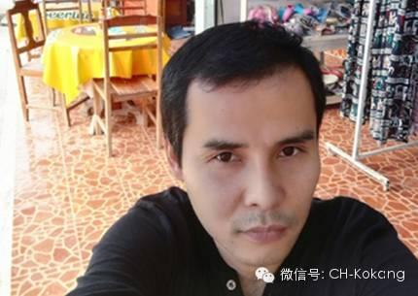

Han activists Lin Gang 林钢 who the firend of MMNDA Peng’s family,his nose and eys not like asian but Jew.

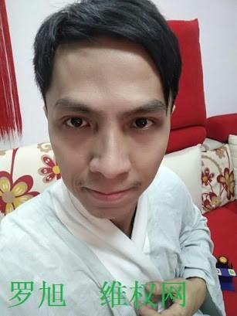

Han Activist leader Zhanhu 战虎 , his nose and eye not like chinese people but Arab DNA

Politics is hard because true allies are rare, that is why the Duterte family can easily be betrayed. But bloodlines are natural political allies. When we, the Han people from the mainland, face difficulties, we seek help from Filipinos, not the Chinese embassy. This is because Filipinos share Han blood, while the Chinese embassy is controlled by people with Manchurian bloodlines.

In the future, when we Han people overthrow the CCP dictatorship, I will also return the favor to our Filipino brothers and sisters. If I return to power in China, I will bring 20 million Filipinos to China. I am a descendant of the Song dynasty royal family, and you are the descendants of the Song exiles. When you return to our ancestral land, you were back to Homeland. But you must promise me not to marry Chinese people. This is because China has been ruled by the Manchurians for over 700 years, and the Han bloodline is no longer pure. The reason I want to immigrate Filipinos to China is to use your pure Han genes to create a truly authentic Chinese population.

When we use the Huang Han movement or Han ethnic liberation movement to fight against the CCP regime, the CCP becomes afraid. On the level of bloodlines, we have everything, while they have nothing.

This is why I advise the Philippine government to treat Han ethnic activists well and, on a moral level, stand up for the Han people on the mainland. As the legitimate successor of Da-Zon, Lu-Zon, to condemn the CCP regime for its racial discrimination, ethnic persecution, and genocide against the Han people. This will send a clear message to the CCP regime: the struggle is no longer limited to the political and military levels; it has now escalated to the level of bloodlines. And at the level of bloodlines, you are an alien, invasive regime in China, and you have nothing.

After we discovered the weaknesses in the political system, we then realized that using bloodlines as a front to fight against the dictatorship had already been hidden in the history of the Han people’s White Lotus Sect. When we understood that we are direct descendants of the Gods, and that the Han State is the only legitimate nation established by divine authority, the struggle against the CCP regime has escalated into a holy war between the Han people and the Manchurians.

Filipino nationalists, you can replicate our success. With just one or two hundred people, you can build political power. The political parties in the Philippines right now are mostly left-wing or far-left-wing. It is same like in China, because the Politicans were Manchurian or Chinese Jew, not local people. The Right-wing is pro-locals, that is why the government against Right-wing.

But you can create a right-wing party based on my theory. Your DNA is Han DNA, and you are also direct descendants of the gods. You deserve a country controlled by the indigenous people, a better government, anti-neo-colonialism and make the Philippines great again. You can also be a little more cunning, like disguising yourself as a left-wing party.

Although you may only have one or two hundred people, once you start publicizing your cause, you’ll find that a bloodline narrative is more effective than a political narrative. Bloodlines are a natural political consensus. When you challenge the political system, those Manchurian politicians will realize that they are actually up against thousands of your fellow countrymen united by bloodlines, and each one of them is their enemy. They are alien invaders.

I cannot directly participate in Filipino politics, but I am willing to help you in any way I can. Because helping you is also helping us. When you grow stronger, the Han people in the Philippines will have protection. This is the meaning of the Hanoy movement.

The sufferings of the Chinese and Filipinos are the same, from same group of people, the Manchurians or Chinese Jews. 亡国之仇，百世可复 If foreign invader destroys your country, even after a hundred generations can take revenge. -From <Gong Yang Sutra> 公羊经